Hydraulic-Induced Scours Around Piers



**investigational project report**

**By**

**Hlulani Sibanda (1091373) & Mathews Zuma** (**1656238)**

**1 AUGUST 2023**

**Supervisor: Professor A. Taigbenu**

# **Abstract**

The scouring phenomenon, induced by hydraulic forces around piers, poses a critical threat to the stability and safety of hydraulic structures like bridges, jetties, and docks. This study examines the factors that influence scour formation and depth around piers, evaluates the effectiveness of riprap as a scour mitigation strategy, and proposes strategies for safeguarding against hydraulic-induced scours. The research objectives encompass analysing the impacts of pier geometry, flow rates, sediment characteristics on scouring, and assessing the effectiveness of riprap as a flow breaker.

The experiment employed various soil types (fine, medium, and coarse-grained) and diverse pier shapes (Circular, Lenticular, Joukowsky, Oblong, and Rectangular) to simulate scouring scenarios. Riprap was used as a flow breaker to mitigate scour. The experiment encompassed variables like flow rate, pier geometry, sediment characteristics, and riprap effectiveness. The collected data included scour characteristics such as depth, shape, and rate, which were analysed to develop guidelines for preventing scour-related failures in hydraulic structures. The findings highlight the pivotal role of pier shape, riprap presence, soil type, and flow rate in scour development. Lenticular pier shape coupled with well-graded medium sand and controlled flow exhibited the least scour, while rectangular pier shape combined with poorly graded medium sand and high flow demonstrated the most significant scour. Furthermore, the study revealed that the scour depth reduction achieved through the implementation of riprap was consistent across various pier shapes, reinforcing its efficacy as a reliable scour mitigation measure.

This research contributes to enhancing hydraulic engineering practices, enabling the design of more resilient and durable pier structures. By considering factors like pier shape, soil type, flow rate, and the use of riprap, designers can mitigate the risk of scour-induced damages and extend the life of hydraulic structures. The findings provide valuable insights for engineering professionals, guiding them to make informed decisions when designing and maintaining hydraulic structures in scour-prone environments. Future studies could further explore parameters like pier positioning, riverbed configurations, and the interaction between these factors and sediment characteristics to comprehensively address the complexities of scour phenomena, promoting safety and longevity in diverse water environments.

Table of Contents

**Abstract** 1

**Chapter 1: Introduction** 3

**Background information** 3

**Chapter 2: Literature Review** 5

**2.1.** **Economic, social and environmental impacts of hydraulic induced scours around piers** 5

2.1.1 Environmental Impacts 5

2.1.2 Social Impacts 5

2.1.3 Economic Impacts 5

**2.2.** **Previous Studies** 6

**2.3.** **Factors that influence the occurrence of hydraulic induced scours around piers** 6

**2.4.** **Mitigation Measures** 9

**Chapter 3: Methodology** 11

**3.1.** **Scouring Experiment and Variables Tested** 11

3.1.1. Experimental Setup 11

3.1.2. Data Collection 13

3.1.3. Scour Mitigation Testing 13

3.1.4. Data Analysis 13

**Chapter 4: Results and Discussion** 14

**4.1.** **Sieve analysis for classifying the soil samples** 14

**4.2.** **Scouring at different flow rates** 17

**4.3.** **Relationship of the parameters to depth of scouring** 19

**4.4.**  **The effect of mitigation measure (Rip-rap)** 23

**Chapter 5: Conclusion and Recommendation** 26

**Recommendations:** 26

**References** 28

**Appendix** 32

Soil samples images: 32

Sieve analysis recoded data 33

Recorded depth of scouring 37

Table with percentage effect of rip-rap 43

Tables with ds/D vs Re 46

# **Chapter 1: Introduction**

The investigation into hydraulic-induced scours around piers addresses numerous crucial issues. It aids in identifying the piers most susceptible to scour, directing targeted attention. Additionally, it deepens our comprehension of intricate scour-driving mechanisms like sediment transport and flow patterns, thereby facilitating the development of more resilient structures. The evaluation of scour risk and the creation of bespoke countermeasures are pivotal outcomes, contributing to effective risk management and compliance with standards and guidelines (Garg et al., 2022; Barkdoll et al., 2007; Lagasse et al., 2009; Meyer, 2008).

Consequently, a comprehensive exploration of hydraulic-induced scouring around piers is essential for refining designs, construction practices, maintenance protocols, and management strategies that uphold infrastructure safety, reliability, and environmental sustainability. The principal aim of this investigation is to attain a holistic understanding of the factors shaping scour occurrence and depth around piers, evaluate riprap's efficacy as a scour mitigation method, and propose secure and sustainable approaches to mitigate hydraulic-induced scours around piers.

## **Background information**

Hydraulic induced scours around piers is a phenomenon that occurs when flowing water removes sediment from around the foundation of the pier (Khwairakpam and Mazumdar, 2009). The scouring effect can lead to a reduction in the stability of the pier and can also lead to the collapse of the pier (Liang and Lee, 2013).

Hydraulic-induced scour around piers is a significant concern that threatens the stability and safety of hydraulic structures like bridges, jetties, and docks (Lagasse et al., 1997). Scouring occurs when water flow erodes sediment from a pier's foundation, potentially leading to structural instability and posing risks to public safety and transportation infrastructure. Bridge failures caused by scour have resulted in substantial economic losses and potential loss of life (FHWA, 2015).

Hydraulic-induced scouring around piers is a significant issue that can lead to bridge failures and jeopardize transportation infrastructure, safety, and the environment. Scour and other hydraulic-induced failures accounted for 60% of bridge failures in the United States between 1966 and 2005, resulting in millions of dollars in repair costs and sometimes direct loss of life (Lagasse et al. 1997; FHWA, 2015). Scour mitigation is crucial in structures built along watercourses and drainage ways, such as bridges. The impact of scouring underscores the need for a comprehensive understanding of its extent and rate. Factors like flow rate, depth, pier shape, and sediment type contribute to the consequences of scouring, including reduced structural capacity and increased maintenance expenses (Hirt and Schubert, 2014).

Inadequate mitigation of scouring poses severe risks, potentially resulting in bridge collapses that imperil watercraft, swimmers, and transportation systems. Implementing effective strategies to ensure pier safety is of utmost importance. The exploration of hydraulic-induced scours around piers assumes a critical role in reinforcing infrastructure resilience, aligning with regulations, curtailing economic and environmental vulnerabilities, and forestalling disruptions to critical infrastructure (Meyer and Weigel, 2011).

This inquiry extends its implications to multiple societal sectors. Engineers and designers can leverage the insights garnered from this research to fortify their designs against water-induced forces and environmental impacts. Transport and infrastructure authorities can enhance their grasp of scour risks linked to vital infrastructure, facilitating the formulation of risk mitigation strategies. This understanding can inform prompt responses and damage mitigation during emergencies. Furthermore, communities can recognize the importance of proactive scour management to safeguard vital connections and mitigate potential economic and social ramifications.

# **Chapter 2: Literature Review**

This literature review examines the various studies that have been conducted on hydraulic induced scours around piers. The review is organized into five sections: the first section provides us with the environmental, economic and social impacts of hydraulic induced scours around piers, The second on looks at the previous studies that have been made on Hydraulic induced scours around piers, the third section looks at the overview of the topic, examines the factors that influence the occurrence of hydraulic induced scours around piers, and the final section highlights the methods that have been developed to mitigate the occurrence of hydraulic induced scours around piers.

## **Economic, social and environmental impacts of hydraulic induced scours around piers**

### 2.1.1 Environmental Impacts

The environmental impacts of hydraulic induced scours around piers are significant. Scouring around piers can lead to the removal of sediment from the bed and bank of a river or channel. The removal of sediment can lead to changes in the morphology of the waterway, which can have adverse effects on the ecosystem of the waterway. For example, the removal of sediment can lead to the loss of habitat for aquatic species, which can have cascading effects on the food web of the waterway (Holland, et al., 2012).

In addition to the loss of habitat for aquatic species, the erosion of sediment can also lead to the release of contaminants into the waterway. The release of contaminants can have adverse effects on the health of aquatic species and can also impact human health if the water is used for drinking or recreation.

### Social Impacts

The social impacts of hydraulic induced scours around piers are also significant. Piers are often important infrastructure that provides access to waterways for transportation, recreation, and fishing. The destabilization of piers due to scouring can lead to disruptions around the pier and the supported superstructure, which can have social and economic impacts on the communities that rely on them.

In addition to shutting down of bridges, the erosion of sediment around piers can also lead to the destabilization of riverbanks, which can have adverse effects on nearby communities. The destabilization of riverbanks can lead to the loss of property and can also increase the risk of flooding (Xie and Levinson, 2011).

### Economic Impacts

The economic impacts of hydraulic induced scours around piers can be significant. Shutting down of bridges due to the destabilization of the pier can have economic impacts on the communities that rely on them for fishing, transportation, and recreation. In addition to the closure of piers, the erosion of sediment can also lead to the need for costly maintenance and repairs to infrastructure such as bridges and dams (Xie and Levinson 2011).

## **Previous Studies**

Numerous studies have investigated hydraulic-induced scouring around bridge piers, using both laboratory experiments and numerical models Xiong and Cai, 2022). Melville and Coleman (2000) conducted a laboratory study to determine the maximum scour depth and pier scour development around cylindrical piers. They found that the maximum scour depth increases as the flow rate and pier diameter increase, while sediment size and pier height decrease. Similarly, Halah and Waqed (2020) used a Flow-3D model to investigate the effects of the bridge pier shape on local scour. The model's ability to predict scour depth around a circular pier was evaluated by comparing its numerical results with laboratory experimental results obtained by Melville in 1975.

The comparison indicated a 10% error rate in the model's predictions, indicating good agreement with the experimental results. The model's findings suggested that the rectangular pier shape caused the most significant scour depth, while the lenticular shape had the least scour depth, about 40% lower than the other shapes. All factors considered had a direct impact on scour, with pier width being the most crucial factor. The maximum scour depth was observed at a pier width ratio of 0.2 for rectangular pier shapes. The results also showed that scour depth was higher upstream and lower downstream. The researchers concluded that pier geometry is a crucial factor in determining the magnitude of scouring around bridge piers.

## **Factors that influence the occurrence of hydraulic induced scours around piers**

Hydraulic induced scour around piers is a complex phenomenon that is influenced by a variety of factors. Scouring around a pier occurs when water flowing around the pier causes sediment to erode from the bed and bank of a river or a channel (Melville and Coleman 2000). The removal of the sediment creates a depression around the pier, which leads to the exposure of the pier foundation. The process of scouring around piers is a natural phenomenon that can be exacerbated by human activities such as the construction of dams, bridges, and other structures that alter the flow of water in a river or a channel.

Hydraulic induced scours around piers are a common problem that has been studied extensively by researchers. The severity of scouring around piers depends on the flow velocity, regime and pattern, the size and shape of the pier, the nature of the sediment around the pier, and the characteristics of the river or channel (Akhlaghi, *et al*., 2020). The severity of scouring can range from minor erosion of the sediment around the pier to the complete collapse of the pier.

The occurrence of hydraulic induced scours around piers is influenced by a variety of factors. Researchers have identified several factors that contribute to the severity of scouring around piers. These factors include the flow of water, the size and shape of the pier, the nature of the sediment around the pier, the characteristics of the river or channel, and the effects of climate change and water temperature.

* + 1. **Flow of water:** The flow of water is one of the most important factors that influence the occurrence of hydraulic induced scours around piers. The flow of water around a pier can create vortices, which can lead to the erosion of the sediment around the pier (Melville and Coleman, 2000). Researchers have shown that the intensity of the vortices depends on the flow velocity and the angle of incidence of the flow (Akhlaghi, *et al*., 2020: Ettema, *et al*., 2011). The intensity of the vortices increases with increasing flow velocity and decreasing angle of incidence of the flow. This means that the risk of scouring around piers is higher in areas where the flow velocity is high and the angle of incidence of the flow is low.
    2. **Size and shape of the pier:** The size and shape of the pier also influence the occurrence of hydraulic induced scours around piers. Researchers have shown that the shape of the pier can affect the intensity of the vortices that are created around the pier (Ettema, *et al*., 2011). Piers that have a circular or cylindrical shape are more prone to scouring than piers that have a rectangular or square shape. This is because circular or cylindrical piers create stronger vortices than rectangular or square piers (Khodashenas, *et al*., 2018)
    3. **Nature of the sediment around the pier:** The size and composition of sediment around a pier also play a crucial role in hydraulic induced scouring. Fine-grained sediments, such as silt and clay, are more susceptible to scouring than coarse-grained sediments, such as sand and gravel. This is because fine-grained sediment is more easily transported by water and has a lower resistance to erosion (Briaud, et al 2001).

The size of sediment particles can also impact scouring. Larger particles, such as cobble or boulder-sized sediment, are more resistant to erosion and transport than smaller particles, such as sand or silt (Bayat, 2017). Thus, piers located in areas with larger sediments may experience less scouring than those located in areas with smaller sediments.

The shape of sediment particles can also influence scouring. Angular particles are more resistant to erosion than rounded particles, as they have more surface area and can interlock with neighbouring particles (Bayat, 2017).

* + 1. **The characteristics of the river or channel:** Hydraulic induced scours around piers can be influenced by factors such as water flow velocity and direction, river or channel depth and width, and sediment load and concentration (Mosley, 1976: Ettema, *et al*., 2011).High water velocities increase erosive forces and can result in more severe scouring around piers, whereas lower velocities can decrease the potential for scouring (Briaud, 2001). Flow direction can also impact scouring, as parallel flow can cause more severe scouring than perpendicular flow (Kirkil, 2008).

Wider and deeper rivers or channels that are at subcritical depth and on a mild slope can decrease water velocity (Taigbenu, 2023). This can lead to less scouring around piers. However, narrow or shallow rivers or channels can constrain water flow, resulting in potentially more severe scouringHigher sediment loads and concentrations can increase the potential for scouring, whereas lower sediment loads and concentrations can reduce the potential for scouring (Scheurer, *et al.,* 2009)

Other factors that may influence hydraulic induced scouring around piers include the presence of other structures or obstructions in the river or channel, as well as the location and orientation of the pier relative to the flow (Akhlaghi, *et al*., 2020)

* + 1. **The effects of climate change and water temperature:** Climate change and changes in water temperature can also affect the formation of hydraulic induced scours around piers. The impact of climate change on hydraulic induced scouring can be complex, and it can depend on factors such as changes in precipitation patterns, increased river flows, and changes in the intensity and frequency of extreme weather events (Nasr, et al., 2021.).

Changes in water temperature can also affect the formation of hydraulic induced scours. Warmer water temperatures can reduce the viscosity of water, leading to lower drag forces and potentially increasing the velocity of water flow. Higher water velocities can increase the potential for scouring around piers, particularly in areas with fine-grained sediment.

Furthermore, changes in water temperature can also affect the stability of sediment around piers. Warmer water temperatures can increase the rate of biogeochemical processes that can alter sediment characteristics, such as the permeability and cohesion of sediment. For example, warming water temperatures can promote the growth of microbes that can alter the composition of sediment and potentially weaken its stability, leading to increased potential for scouring around piers (Sheppard, *et al.,* 2004).

In addition, climate change can also affect the sediment load and concentration in rivers and channels, which can impact the potential for scouring. Changes in precipitation patterns, increased river flows, and changes in land use can all alter the sediment load and concentration in rivers and channels, potentially leading to increased scouring around piers.

## **Mitigation Measures**

To prevent scour around bridge piers, different methods can be used, including upstream or downstream channel control, armouring, flow modification, bridge modification, and drainage control. Upstream channel control can be achieved by using structures such as spur dikes, hard points, or vanes that redirect the flow and prevent the channel from shifting and causing erosion around the bridge. For downstream control, a weir or check dam can be used to prevent head-cuts from moving upstream and damaging the bridge. Armouring involves using riprap or cable-tied blocks to prevent soil erosion. Bridge modification may include adding an extra span to increase the flow area, while flow modification entails using walls or other structures to guide the flow smoothly through the bridge opening. Drainage control ensures that there are no adverse impacts from drainage water around the bridge (Barkdoll, et al., 2007).

When selecting a countermeasure, several factors should be considered, such as technical effectiveness, ease of construction, durability, maintenance, aesthetics, environmental impact, and cost. Some examples of scour countermeasures include grouted riprap, pile-supported aprons, and collar-type scour protection (Barkdoll, et al., 2007).

**Riprap and Gabions**: Using riprap is an unsurpassed method used to protect the pier foundations from scouring. It involves the use of stones or concrete blocks to dissipate the energy of the water and prevent scouring, similar to Gabions which are wire mesh baskets filled with rocks or other materials. The baskets cause turbulence in the water flow, which slows it down and reduces the force of the current. The size and shape of the riprap are chosen based on the expected flow velocity and sediment size. Grouted riprap involves placing riprap in a grout-filled trench to improve its stability and increase its effectiveness (Brown and Clyde 1989)

Pile-supported aprons are typically used in deep water or high-velocity areas and consist of a series of piles and concrete blocks that create a barrier around the pier. Collar-type scour protection involves placing a collar around the pier to deflect the flow of water and reduce scouring.

**Bed sills:** The depth of scour by limiting the flow of water around the pier and lowering the velocity of the water at the bed level. Several studies have demonstrated that bed sills are helpful in reducing the depth of scour around bridge piers. Melville and Coleman (2000) discovered, for example, that using a bed sill on a pier reduced the depth of scour by up to 90%. Bed sills can also help reduce scour depth over time. Yoon and Kang (2014) discovered that bed sills decreased the rate of scour formation around bridge piers. The scour depth around a pier without a bed sill increased dramatically over time, whereas the scour depth around a pier with a bed sill stayed relatively constant. This implies that bed sills can aid in stabilizing the scour depth and preventing further erosion near bridge piers.

**Dredging:** Periodic dredging of the area around the pier is one of the measures that can be used to effectively address scouring. Regular inspections and monitoring of scour conditions can also aid in identifying and addressing potential problems before they become more serious. (Hirt & Schubert, 2014).

**Scour monitoring systems** involve the use of sensors and monitoring equipment to measure the depth of scouring around the pier continuously (Raudkivi & Ettema, 1983). The data obtained can be used to assess the effectiveness of the mitigation measures and identify areas that require additional protection

# **Chapter 3: Methodology**

The central emphasis of this research is to examine the phenomenon of hydraulic-induced scouring around piers while also assessing the viability of riprap as a potential measure for mitigating such scouring effects. To accomplish this, the research will be carried out through a laboratory experiment, with the ultimate aim of addressing the following specific research objectives:

1. **Effect of Pier Geometry and Flow Rate:** Analyse how the geometric shape of the pier and flow rate influence scouring around piers.
2. **Influence of Sediment Characteristics:** Examine the impact of sediment characteristics on the depth of erosion around piers.
3. **Effectiveness of Riprap as a Flow Breaker:** Evaluate the effectiveness of riprap in preventing scour damage to piers.

## **3.1. Scouring Experiment and Variables Tested**

In the laboratory experiment, different types of pier shapes will be placed in different soils (fine, medium, and coarse-grained) to examine the scour depths for various flow rates. Riprap will be used as the flow breaker to simulate a scour mitigation measure.

The variables evaluated in the experiment include flow rate, pier geometry, sediment characteristics, and the effectiveness of riprap as a flow breaker. Scour characteristics, such as depth, shape, and rate, will be measured and recorded for each simulation. The collected laboratory data will be analyzed to develop guidelines and best practices for designing and maintaining hydraulic structures to prevent scour-related failures, with a specific focus on the effectiveness of riprap as a scour mitigation measure.

### 3.1.1. Experimental Setup

Apparatus:

* The open flume channel setup (see Figure 3.1)
* 6 different types of soil were used and a sieve analysis was carried out on each soil type i.e. they were graded between poorly or good and (fine-grained, medium-grained, and coarse-grained).
* 5 pier models of various shapes were used: Circular, Lenticular, Joukowsky, Oblong and Rectangular (See Figure 3.2)
* Riprap (See Figure 3.3)

**Open channel set up**

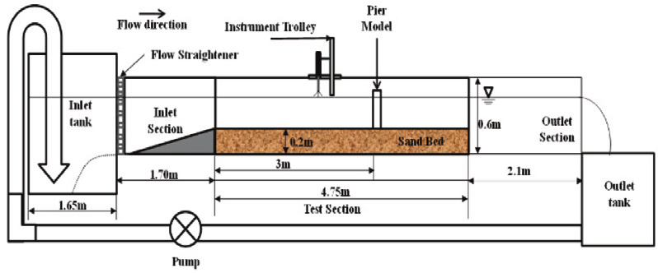

***Figure 3.1: The open channel set up***

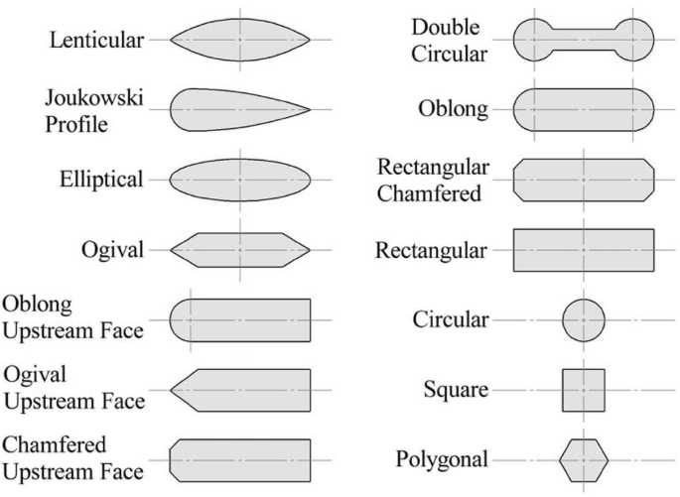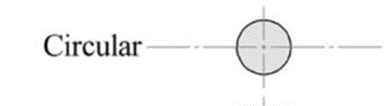

48mm

46mm

48mm



36mm

48mm

***Figure 3.2: Pier shapes used for this study***

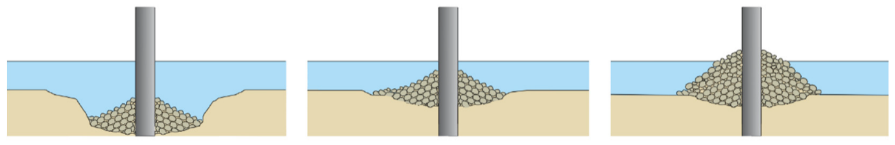

***Figure 3.3: Rip-rap around pier shapes***

### 3.1.2. Data Collection

1. Soil Classification: Soil samples were subjected to sieve analysis to classify and characterize them. The grading categorized soil samples as either poor or good, and further classified them as fine-grained, medium-grained, or coarse-grained.
2. Each soil sample was loaded and levelled into an open channel. The first pier shape was positioned at the channel's centre.
3. The datum was established on the soil surface.
4. Four flow rates were taken at four water depths. A two-minute interval was observed between each flow rate to achieve steady flow, and then measurement of the scour depth upstream of the pier was taken.

### 3.1.3. Scour Mitigation Testing

1. Riprap was applied around the pier shapes.
2. For the maximum flow rate, water depth and the decrease in riprap height upstream were recorded.
3. Steps 2 to 6 were repeated for all five pier shapes in each soil sample.

### 3.1.4. Data Analysis

The collected laboratory data and scour mitigation test data were analysed. The analyses aim to develop comprehensive design and maintenance guidelines for hydraulic structures, specifically addressing scour-induced failures. The findings may also lead to recommendations based on the observed outcomes.

# **Chapter 4: Results and Discussion**

The outcomes derived from the experimentation are visually presented in the form of graphs and tabulated data, which are subsequently subjected to in-depth discussions.

## **4.1. Sieve analysis for classifying the soil samples**

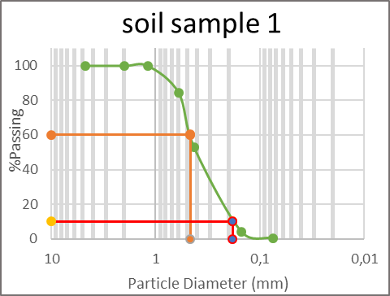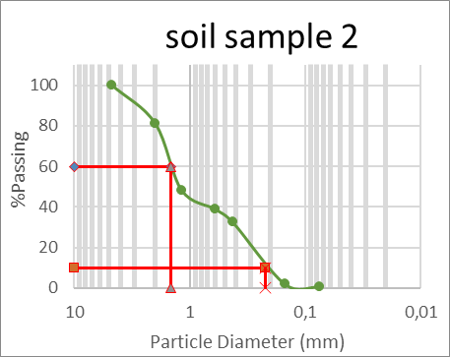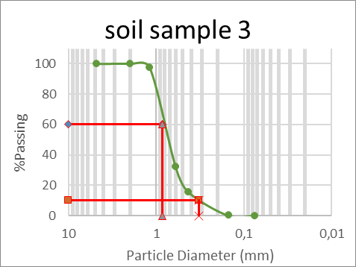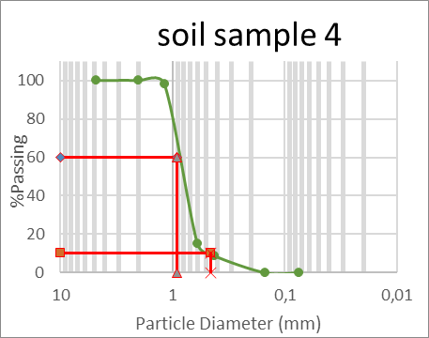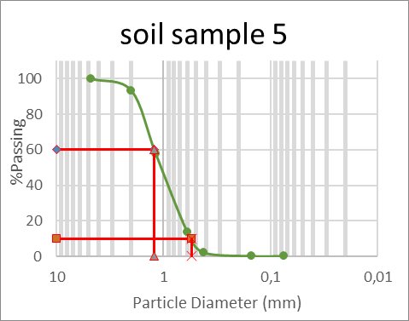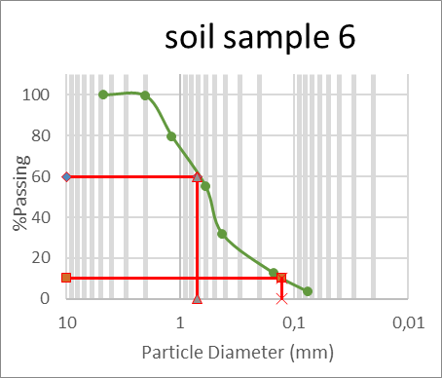***Figure 4.1: Particle size distribution curves for the soil used***

By analysing the particle size distribution curves depicted in Figure 4.1, we determined the average, smallest, and largest particle sizes within the soil samples. These curves effectively visualize the quantity of material that passed through each sieve, ranging from 4.75mm down to 0.075mm.

***Table 4.1: Cu and Cc coefficient for well graded soil***

|  |  |  |
| --- | --- | --- |
| **Well Graded soil** | | |
| Gravel | Cc = 1-3 | Cu>4 |
| Sand | Cc = 1-3 | Cu>6 |

***Table 4.2: Calculated Cu and Cc of soils used for this research***

|  |  |  |  |  |  |  |
| --- | --- | --- | --- | --- | --- | --- |
| **soil sample 1** | | | | | |  |
| %Gravel | 0,00 | D60(mm) | 0,46 | **Cu**=D60/D10 | | 2,54 |
| %Sand | 99,50 | D30(mm) | 0,30 | **Cc** = D30^2/D10*D60 | | **1,03** |
| %Fines | 99,50 | D10(mm) | 0,18 |  |  |  |
| **soil sample 2** | | | | | |  |
| %Gravel | 0,00 | D60(mm) | 1,47 | **Cu**=D60/D10 | | 6,64 |
| %Sand | 99,29 | D30(mm) | 0,40 | **Cc** = D30^2/D10*D60 | | **0,50** |
| %Fines | 99,29 | D10(mm) | 0,22 |  |  |  |
| **soil sample 3** | | | | | |  |
| %Gravel | 0 | D60(mm) | 0,85 | **Cu**=D60/D10 | | 2,58 |
| %Sand | 100 | D30(mm) | 0,58 | **Cc** = D30^2/D10*D60 | | **1,20** |
| %Fines | 100 | D10 (mm) | 0,33 |  |  |  |
| **soil sample 4** | | | | | |  |
| %Gravel | 0 | D60 (mm) | 0,91 | **Cu**=D60/D10 | | 2,00 |
| %Sand | 100 | D30 (mm) | 0,70 | **Cc** = D30^2/D10*D60 | | **1,19** |
| %Fines | 100 | D10 (mm) | 0,46 |  |  |  |
| **soil sample 5** | | | | | |  |
| %Gravel | 0 | D60 (mm) | 1,23 | **Cu**=D60/D10 | | 2,26 |
| %Sand | 100 | D30 (mm) | 0,82 | **Cc** = D30^2/D10*D60 | | **0,99** |
| %Fines | 100 | D10 (mm) | 0,54 |  |  |  |
| **soil sample 6** | | | | | |  |
| %Gravel | 0 | D60 (mm) | 0,71 | **Cu**=D60/D10 | | 6 |
| %Sand | 96,38 | D30 (mm) | 0,40 | **Cc** = D30^2/D10*D60 | | **1,76** |
| %Fines | 96,38 | D10 (mm) | 0,13 |  |  |  |

The classification of the soil samples is presented in the table below:

***Table 4. 3: classified soil samples***

| **Soil Classification** | **Grading** |
| --- | --- |
| Soil Sample 1 | poorly graded –Fine sand |
| Soil Sample 2 | well graded -Medium sand |
| Soil Sample 3 | poorly graded –Medium sand |
| Soil sample 4 | poorly graded -Medium sand |
| Soil sample 5 | poorly graded -Medium sand |
| Soil sample 6 | Well graded -Medium sand |

After completing the sieve analysis and gathering the necessary data, the subsequent step involved calculations to determine essential parameters such as the average particle size (D50), D60, and D10. These calculated values are presented in Table 4.2. To assign appropriate classifications to the soil samples, we utilized the acquired D50 values in conjunction with the reference values from Table 4.1. This classification process, based on specific criteria, allowed us to categorize the soil samples according to their grading. The resulting classifications are detailed in Table 4.3.

This classification procedure takes into account the complete spectrum of particle sizes encompassed in the soil samples. By doing so, it provides a profound understanding of the composition of these soil samples and their potential behaviour, particularly when subjected to hydraulic processes. For a more visual representation of the soil samples, we have included images in the first page of the appendix. These images offer additional clarity and aid in comprehending the nature of the soil samples under investigation.

## **4.2. Scouring at different flow rates**

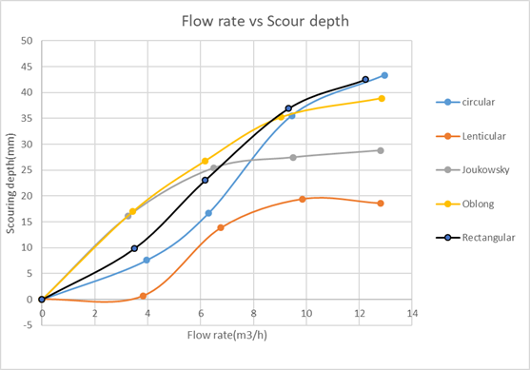Soil sample 1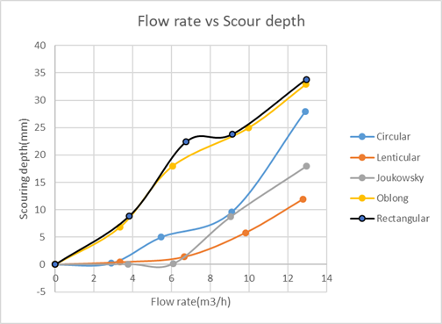Soil sample 2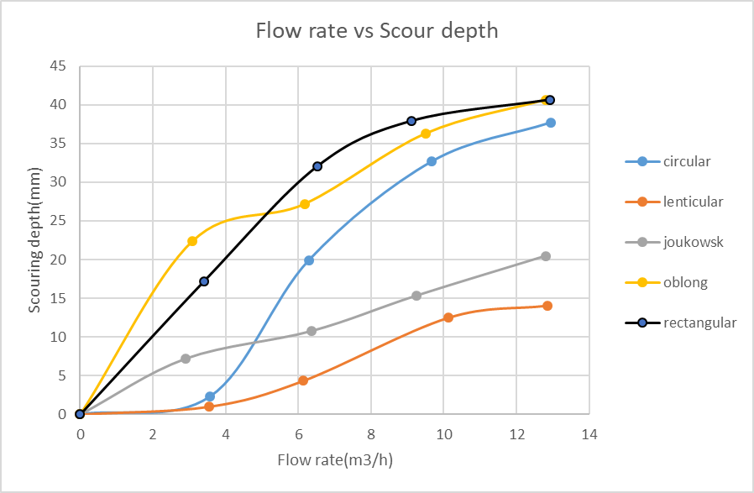Soil sample 3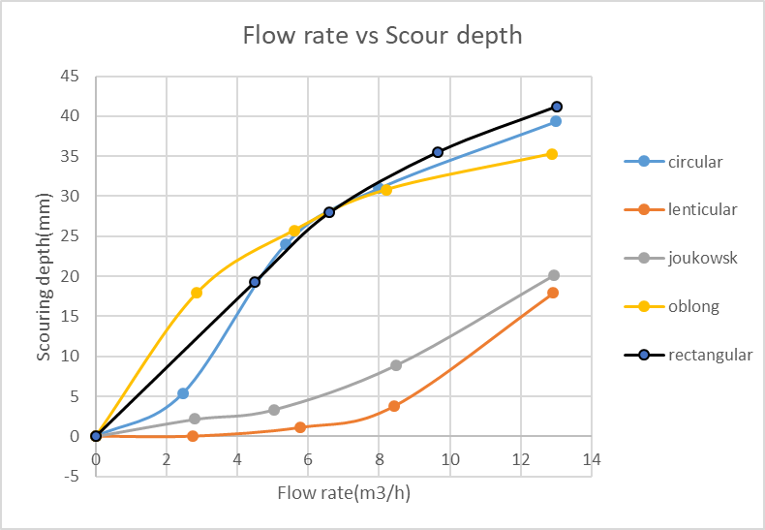Soil sample 4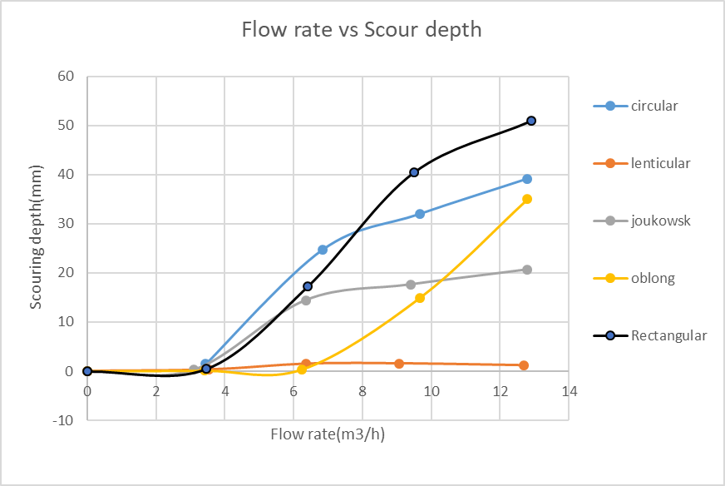Soil sample 5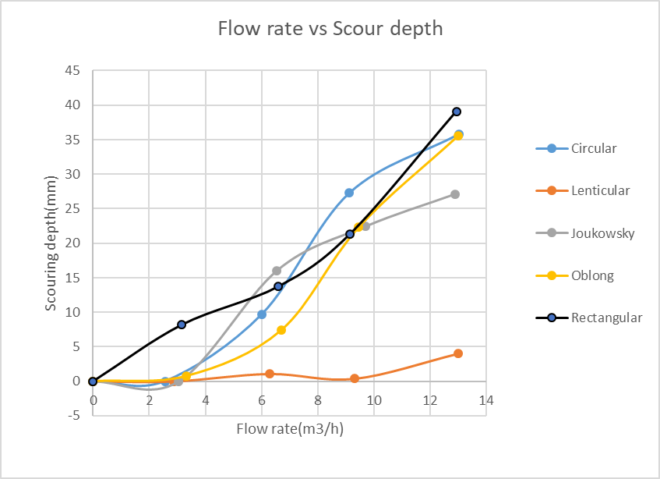Soil sample 6

***Figure 4.2: Influence of the flow rate on the depth of scour***

Examining Figure 4.2 reveals a clear correlation between flow rate and scour depth. As the flow rate increases, there is a corresponding increase in scour depth. It is worth noting that, while this trend holds true across different soil samples, the rate of increase in scour depth varies between them. Soil samples 5 and 6, for instance, exhibit a somewhat delayed response to increasing flow rates, indicating that larger flow rates are required to initiate scour in these cases.

At low flow rates, the kinetic energy of the water is insufficient to significantly erode the sediment around the pier. As a result, scouring is minimal, and any scour depth increase is gradual. With a moderate increase in flow rate, the kinetic energy of the water increases, allowing it to gradually erode the sediment around the pier. Scouring begins to intensify, resulting in a noticeable but not significant increase in scour depth. As the flow rate further increases, the flow exerts higher forces on the sediments, causing substantial erosion around the pier. Consequently, scouring deepens more rapidly with increasing flow rates.

There is a point at which the flow rate becomes critical for sediment entrainment. Beyond this point, even slight increases in flow rate can lead to disproportionately larger scour depths. This critical flow rate marks the transition to a more rapid and substantial increase in scouring.

Since the impact of flow rate on scour depth can be influenced by multiple factors, including sediment characteristics and pier geometry, the exact behaviour of scour around piers is influenced by these factors. The observed delay in scour initiation in certain soil samples exemplifies this complexity, emphasizing the need to consider these factors holistically when assessing the influence of flow rate on scour depth.

***Figure 4.3: Maximum scour depth for different pier shapes and soil types***

The bar graph in Figure 4.3 distinctly illustrates that the lenticular pier shape consistently generates shallower scouring depths across various flow rates when compared to the other pier shapes. This trend is particularly noticeable upstream of the pier. Among the other pier shapes, the Joukowsky shape exhibits the next lowest scouring depths, followed by the oblong and circular shapes. In contrast, the rectangular shape consistently produces higher scouring depths.

This phenomenon can be attributed to the characteristics of the pier shapes. The rectangular shape, with its sharp edges, induces turbulent flows around the pier, leading to substantial soil erosion. The turbulence intensifies the erosive effects of the flowing water. In contrast, the lenticular shape's streamlined design minimizes the creation of turbulent flows around the pier. This results in reduced erosion of the surrounding soil, contributing to the observed shallower scouring depths.

The findings underscore the significance of pier shape in influencing scouring patterns upstream of the pier. Shapes with streamlined characteristics, such as the lenticular and Joukowsky shapes, tend to mitigate turbulence in the wake region (upstream of the pier) and subsequently reduce scouring effects. On the other hand, pier shapes with pronounced edges, like the rectangular shape, tend to induce turbulence, causing more substantial soil erosion. This understanding is pivotal in designing hydraulic structures that can withstand the erosive forces of flowing water and maintain their stability over time.

## **4.3. Relationship of the parameters to depth of scouring**

For this experiment, the parameters that seem to show a significant effect on scour depth are the flowrate, sediment size, presence of riprap, grading of soil, depth of flow, pier shape, pier width and time**.** In our experiment the depth of local scour can be expressed in terms of these parameters:

$\frac{ds}{D}=f(Q,d50,V,h, Ks$***)***  (4.1)

Where: *Q* = Flowrate

*d*50 = Average bed sediment size

*h* = Depth of flow

*Ks* = Shape parameter of the pier

*D* = Effective diameter of the pier

Equation 4.2, which relates the dimensionless scour depth to the Reynolds number, *Re*, is proposed by using the experimental data obtained from the study

***dS / D = αReβ***  (4.2)

Where: *Re* = *Vh*/ν,

*V* is the average velocity

*h* is the water depth and

*ν* is the kinematic viscosity

α and β are parameters are obtained from the plots in Figure 4.4

***Figure 4.4: Variation of the dimensionless scour depth with Reynolds number***

The relationship between Reynolds numbers (*Re*) and the dimensionless scour depth (*ds*/*D*) is visualized in Figure 4.4. Notably, the data analysis reveals for Reynolds numbers ranging from approximately 1500 to around 6000, the R2 values remain consistently close to each other, hovering around 0.9 across all soil samples. This indicates a good correlation between Reynolds numbers within this range and the resulting dimensionless scour depths, implying that the scouring behaviour is relatively predictable for these conditions.

However, it is worth noting that soil sample 5 displays a slightly different trend, with R2 with values that are about 0.8. This suggests that the relationship between Reynolds numbers and dimensionless scour depths might be influenced by unique characteristics of this particular soil sample. The utilization of a power trend line for the data provides a mathematical representation of this relationship. The power trend line captures the nonlinear relationship between Reynolds numbers and scour depths, which is expected due to the intricate interactions of flow dynamics and sediment transport around pier shapes.

## **4.4. The effect of mitigation measure (Rip-rap)**

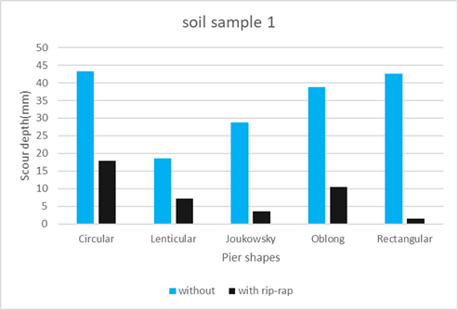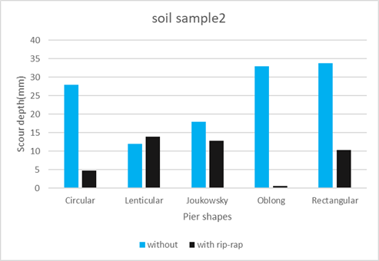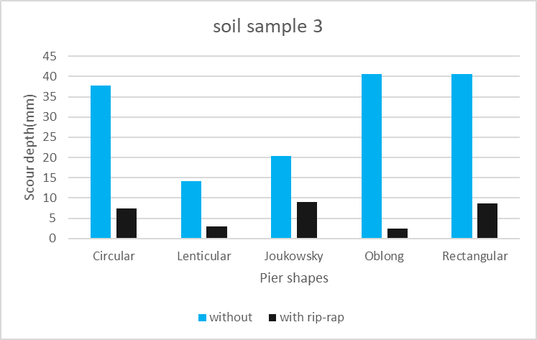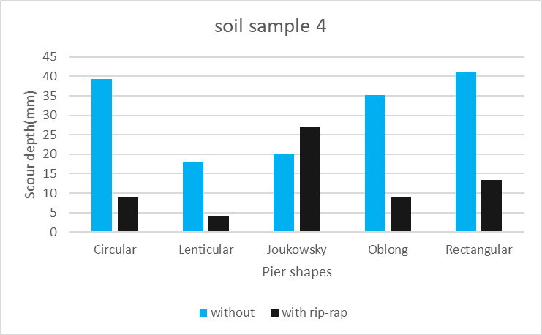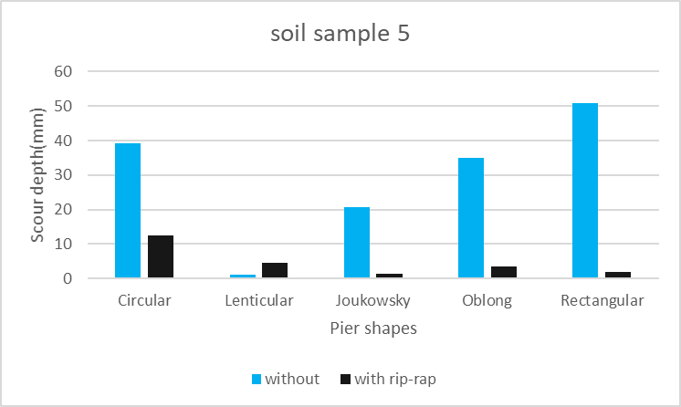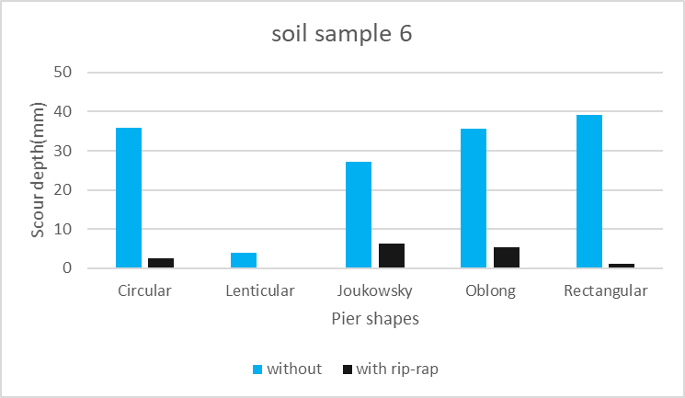

***Figure 4.5: Scour depths with and without Rip-rap***

The influence of the scour mitigation measure, specifically rip-rap, is depicted through the bar graphs in Figure 4.5. These graphs provide a clear comparative view of scour depths with and without the application of rip-rap around the pier shapes. The data presented in Figure 4.5 show a consistent trend: scour depths are notably higher in scenarios without rip-rap compared to those with rip-rap. This indicates that the implementation of rip-rap as a flow-interrupting measure leads to a substantial reduction in scour depth. Such a reduction is of paramount importance for maintaining the integrity of the pier foundations and, by extension, the entire hydraulic structure.

However, it is important to highlight instances where the scour depth with the presence of rip-rap appears to exceed that without rip-rap. This occurrence can likely be attributed to minor errors in data collection during the laboratory experimentation phase, particularly during the process of sand levelling and datum recording. These small discrepancies are amplified when the measured scour depth is small, as in the case of the lenticular pier (Figure 4.6).

***Figure 4.6: The effect of the riprap for different pier shapes and soils***

In our effort to counteract scouring around the piers, we implemented riprap as a protective measure. Figure 4.6 demonstrates a comparison of the percentage impact of riprap on the depth of scouring. Across various pier shapes, the presence of riprap consistently resulted in a reduction of 50% or more in scouring depth. This substantial reduction indicates that flow-interrupting measures like riprap significantly contribute to curbing the impact of the flow on scour around piers, thereby minimizing erosion upstream of the piers.

It is worth noting that in the case of soil sample 3, which is poorly graded and of medium sand, an unusually large negative percentage was observed. This might be attributed to potential errors in the laboratory investigation, stemming from the recording of a depth prior to scouring that was less than the depth following the implementation of riprap.

The impact of rip-rap on scour depth is significant in terms of hydraulic structure stability. Rip-rap, characterized by its rugged, irregular shape and ability to dissipate energy, serves as an effective flow breaker. It redistributes the flow kinetic energy, reducing its erosive potential on the sediment bed. This alteration in flow dynamics impedes the development of high-velocity flow zones that typically induce scour. In cases where the pier shapes are surrounded by rip-rap, the velocity and force of water currents are hindered, preventing excessive erosion of sediment around the pier foundations. Consequently, the depth of scour is diminished, leading to enhanced structural resilience.

***Figure 4.7: Maximum scour depths for different soil types***

**Soil Sample 5 (Poorly Graded Medium Sand):** This soil type, characterized by being poorly graded and composed of medium sand, consistently produces high scour depths. Poorly graded soils contain a limited range of particle sizes, resulting in a more uniform and tightly packed sediment structure. This compactness makes it easier for flowing water to dislodge and transport the sediment particles, leading to increased scouring. Additionally, the cohesive nature of fine particles in this sample further contributes to their erosion and transportation.

**Soil Sample 1 (Poorly Graded Fine Sand):** Comprising fine sand and classified as poorly graded, soil sample 1 follows a similar trend by yielding relatively high scour depths. Fine sand particles have cohesive properties, making them susceptible to being bound together within the sediment bed. While these particles might not be as easily entrained by the flow, their cohesiveness leads to them being more prone to erosion and detachment, resulting in significant scour.

**Soil Samples 2 and 6 (Well Graded Medium Sand):** These soil samples, identified as well graded and composed of medium sand, exhibit a consistent behaviour of generating lower scour depths. Well-graded soils encompass a wider range of particle sizes, contributing to a more open and porous sediment arrangement. This increased porosity permits better water infiltration and reduces the erosive potential of the flow. Coarser particles within this type of soil can act as protective armour, dispersing the energy of the flow and reducing direct erosion of the underlying sediment. The medium-sized particles are less cohesive and more easily transported, limiting sediment accumulation that could lead to extensive scour.

Figure 4.7 visually portrays this behaviour, confirming that the poorly graded medium sand (sample 5) and poorly graded fine sand (sample 1) result in higher scour depths. Conversely, the well-graded medium sand (samples 2 and 6) displays a trend of generating lower scour depths.

# **Chapter 5: Conclusion and Recommendation**

In this study, the phenomenon of hydraulic-induced scouring around piers was comprehensively investigated through laboratory experimentation. The main research objectives were achieved, shedding light on the intricate dynamics of scour formation, the influence of sediment characteristics, the effectiveness of riprap as a mitigation measure, and the impact of various pier shapes. The following key conclusions can be drawn from the study:

**Flow Rate and Scour Depth Relationship:** The experimental results revealed a clear positive correlation between flow rate and scour depth. As flow rate increases, scour depth also increases, albeit at varying rates across different soil samples. The response of soil samples 5 and 6 highlighted the complexity of this relationship, with larger flow rates required to initiate scour in these cases.

**Pier Geometry's Role:** The study demonstrated that pier geometry plays a crucial role in influencing scour patterns. The lenticular pier shape consistently exhibited shallower scour depths, while the rectangular shape consistently led to higher scour depths. The streamlined designs of certain pier shapes reduced turbulence and subsequent soil erosion, contributing to shallower scour

**Effectiveness of Riprap:** The application of riprap as a flow-interrupting measure was found to significantly reduce scour depths. This mitigation measure proved effective in preventing extensive erosion around pier shapes. Instances of higher scour depths with riprap were attributed to potential errors in data collection.

**Sediment Characteristics and Scour:** Sediment characteristics significantly influenced scouring behaviour. Poorly graded fine and medium sands exhibited higher scour depths due to their cohesive nature and tighter sediment structure. Well-graded medium sands, on the other hand, displayed lower scour depths due to their greater porosity and reduced erosive potential.

## **Recommendations:**

The insights derived from this research provide valuable recommendations that can significantly enhance the understanding and management of hydraulic-induced scouring around piers. By taking these recommendations into consideration, engineers, designers, and authorities can develop more effective strategies to mitigate the risks associated with scouring:

**1. Pier Geometry and Mitigation Measures:**

Engineers and designers should exercise careful consideration of pier geometry. The preference for streamlined shapes, such as the lenticular pier shape, can contribute to reducing scour effects. Additionally, the implementation of riprap as a proven mitigation measure is strongly recommended to effectively diminish scouring effects. Riprap acts as a buffer, dissipating the erosive forces of the water and safeguarding the stability of pier foundations.

**2. Flow Rate Assessment and Monitoring:**

The study underscores the importance of assessing flow rates in hydraulic structures. To anticipate and prevent potential scouring, it is crucial to implement monitoring systems that continuously measure flow rates and scour depths around piers. This proactive approach enables timely interventions, preventing excessive erosion and ensuring the long-term integrity of hydraulic structures.

**3. Sediment Characteristics Evaluation:**

In the planning phase of hydraulic structures, a thorough evaluation of sediment characteristics is essential. Soil samples with finer particles and poor grading are inherently more susceptible to scouring. Hence, incorporating preventive measures such as riprap or alternate stabilizing methods becomes imperative to counteract erosion and enhance structural resilience.

**4. Future Research and Comprehensive Analysis:**

This study unveils the complexity of scouring behaviour, influenced by multiple interrelated factors. Future research endeavours should explore the combined effects of sediment compaction, cohesion, and different riprap configurations. Rather than isolating these factors, a comprehensive analysis considering their interaction is likely to yield more accurate and nuanced insights into scouring processes.

**5. Enhanced Experimental Procedures:**

It is worth noting that the study acknowledges the potential for errors during laboratory experimentation, particularly during the processes of sand levelling and datum recording. To mitigate such errors, conducting additional experiments with meticulous attention to data collection procedures can enhance the reliability of findings.

By adopting these recommendations, stakeholders can ensure greater resilience, safety, and sustainability of these crucial infrastructural elements. Through the combined efforts of engineers, researchers, and policymakers, hydraulic-induced scouring's impact can be minimized, ultimately contributing to the longevity and efficiency of hydraulic systems.

# **References**

Akhlaghi, E., Babarsad, M.S., Derikvand, E. and Abedini, M., 2020. Assessment the effects of different parameters to rate scour around single piers and pile groups: a review. Archives of Computational Methods in Engineering, 27(1), pp.183-197.

Aksoy, A.O. and Eski, Ö. (2016) “Experimental investigation of local scour around circular bridge piers under steady state flow conditions,” Journal of the South African Institution of Civil Engineering, 58(3), pp. 21–27. Available at: https://doi.org/10.17159/2309-8775/2016/v58n3a3. (Accessed: 10 march 2023)

Arneson, L.A., Zevenbergen, L.W., Lagasse, P.F. and Clopper, P.E., 2012. Hydraulic engineering circular no. 18: evaluating scour at bridges. US Department of Transportation.

Bayat, A., 2017. Erosion behavior and scour risk of extremely coarse streambeds.

Bird, J.F. and Bommer, J.J., 2004. Earthquake losses due to ground failure. Engineering geology, 75(2), pp.147-179.

Brandimarte, Luigia & Paron, Paolo & Di Baldassarre, Giuliano. (2012). Bridge pier scour: A review of processes, measurements and estimates. Environmental engineering and management journal. 11. 10.30638/eemj.2012.121.

Briaud, J.L., Ting, F.C.K., Chen, H.C., Cao, Y., Han, S.W. and Kwak, K.W., 2001. Erosion function apparatus for scour rate predictions. Journal of geotechnical and geoenvironmental engineering, 127(2), pp.105-113.

Brown, S.A. and Clyde, E.S., 1989. Design of riprap revetment (No. FHWA-IP-89-016). United States. Federal Highway Administration.

Ettema, R., Melville, B.W. and Constantinescu, G., 2011. Evaluation of bridge scour research: Pier scour processes and predictions. Washington, DC, USA: Transportation Research Board of the National Academies.

Garg, R.K., Chandra, S. and Kumar, A., 2022. Analysis of bridge failures in India from 1977 to 2017. Structure and Infrastructure Engineering, 18(3), pp.295-312.

Hansen, E.A. et al. (2007) Scour Protection around Offshore Wind Turbine Foundations, Full-Scale Measurements. Available at: https://www.researchgate.net/publication/238664460_Scour_Protection_around_Offshore_Wind_Turbine_Foundations_Full-Scale_Measurements. (Accessed: 10 march 2023)

Holland, A., Duivenvoorden, L.J. and Kinnear, S.H., 2012. Naturally acidic waterways: conceptual food webs for better management and understanding of ecological functioning. Aquatic conservation: Marine and freshwater Ecosystems, 22(6), pp.836-847.

Jalal, H.K. and Hassan, W.H., 2020. Effect of bridge pier shape on depth of scour. In IOP conference series: materials science and engineering (Vol. 671, No. 1, p. 012001). IOP Publishing.

Jalal, H.K. and Hassan, W.H., 2020. Effect of bridge pier shape on depth of scour. In IOP conference series: materials science and engineering (Vol. 671, No. 1, p. 012001). IOP Publishing.

Khodashenas, S.R., Shariati, H. and Esmaeeli, K., 2018. Comparison between the circular and square collar in reduction of local scouring around bridge piers. In E3S Web of Conferences (Vol. 40, p. 03002). EDP Sciences

Khodashenas, S.R., Shariati, H. and Esmaeeli, K., 2018. Comparison between the circular and square collar in reduction of local scouring around bridge piers. In E3S Web of Conferences (Vol. 40, p. 03002). EDP Sciences

Khwairakpam, P. and Mazumdar, A., 2009. Local scour around hydraulic structures. International Journal of Recent Trends in Engineering, 1(6), p.59.

Kirkil, G., Constantinescu, S.G. and Ettema, R., 2008. Coherent structures in the flow field around a circular cylinder with scour hole. Journal of Hydraulic Engineering, 134(5), pp.572-587.

Koehnken, L., Rintoul, M.S., Goichot, M., Tickner, D., Loftus, A.C. and Acreman, M.C., 2020. Impacts of riverine sand mining on freshwater ecosystems: A review of the scientific evidence and guidance for future research. River Research and Applications, 36(3), pp.362-370.

Lagasse, P.F., Clopper, P.E., Pagan-Ortiz, J.E., Zevenbergen, L.W., Arneson, L.A., Schall, J.D. and Girard, L.G., 2009. Bridge scour and stream instability countermeasures: experience, selection, and design guidance: Volume 2 (No. FHWA-NHI-09-112). National Highway Institute (US).Meyer, M.D., 2008. Design standards for US transportation infrastructure: The implications of climate change.

Liang, Z. and Lee, G.C., 2013. Bridge pier failure probabilities under combined hazard effects of scour, truck and earthquake. Part I: Occurrence probabilities. Earthquake Engineering and Engineering Vibration, 12(2), pp.229-240.

Melville, B. W., & Coleman, S. E. (2000). Bridge Scour. Water Resources Publications, LLC.

Melville, B.W., and Raudkivi, A.J. (1977). "Flow characteristics in local scour at bridge piers." Journal of Hydraulic Research, vol. 15, no. 4, pp. 395-412.

Melville, B.W., and Raudkivi, A.J. (1977). "Flow characteristics in local scour at bridge piers." Journal of Hydraulic Research, vol. 15, no. 4, pp. 395-412.

Meyer, M.D. and Weigel, B., 2011. Climate change and transportation engineering: Preparing for a sustainable future. Journal of Transportation Engineering, 137(6), pp.393-403.

Mosley, M.P., 1976. An experimental study of channel confluences. The journal of geology, 84(5), pp.535-562.

Moussa, A.M.A., 2018. Evaluation of local scour around bridge piers for various geometrical shapes using mathematical models. Ain Shams Engineering Journal, 9(4), pp.2571-2580.

Moussa, A.M.A., 2018. Evaluation of local scour around bridge piers for various geometrical shapes using mathematical models. Ain Shams Engineering Journal, 9(4), pp.2571-2580.

Nasr, A., Björnsson, I., Honfi, D., Larsson Ivanov, O., Johansson, J. and Kjellström, E., 2021. A review of the potential impacts of climate change on the safety and performance of bridges. Sustainable and Resilient Infrastructure, 6(3-4), pp.192-212.

Prowse, T.D., Wrona, F.J., Reist, J.D., Gibson, J.J., Hobbie, J.E., Lévesque, L.M. and Vincent, W.F., 2006. Climate change effects on hydroecology of Arctic freshwater ecosystems.

Raudkivi, A. J., & Ettema, R. (1983). Clear-water scour at bridge piers. Journal of hydraulic engineering, 109(3), 338-350.

Rossini, M., Matta, F., Nolan, S., Potter, W. and Nanni, A., 2020. AASHTO design specifications for GFRP-RC bridges. In Proceedings of Italian Concrete Days 2018 (pp. 432-444). Springer International Publishing.

S, F.H.A. and S, F.T.A. (2017) 2015 Status of the Nation’s Highways, Bridges, and Transit Conditions and Performance Report to Congress. Government Printing Office.

Scheurer, K., Alewell, C., Bänninger, D. and Burkhardt-Holm, P., 2009. Climate and land-use changes affecting river sediment and brown trout in alpine countries—a review. Environmental Science and Pollution Research, 16, pp.232-242.

Sheppard, D.M., Odeh, M. and Glasser, T., 2004. Large scale clear-water local pier scour experiments. Journal of Hydraulic Engineering, 130(10), pp.957-963.

Sheppard, D.M., Odeh, M. and Glasser, T., 2004. Large scale clear-water local pier scour experiments. Journal of Hydraulic Engineering, 130(10), pp.957-963.

Tafarojnoruz, A., Gaudio, R. and Calomino, F. (2012) “Evaluation of Flow-Altering Countermeasures against Bridge Pier Scour,” Journal of Hydraulic Engineering, 138(3), pp. 297–305. Available at: https://doi.org/10.1061/(asce)hy.1943-7900.0000512. (Accessed: 21 march 2023)

Tafarojnoruz, A., Gaudio, R. and Calomino, F. (2012) “Evaluation of Flow-Altering Countermeasures against Bridge Pier Scour,” Journal of Hydraulic Engineering, 138(3), pp. 297–305. Available at: https://doi.org/10.1061/(asce)hy.1943-7900.0000512. (Accessed: 21 march 2023)

Taigbenu, A. 2023. Uniform flow- Open channel flow, Hydraulic Engineering (CIVN4010A). University of the Witwatersrand. March

Taigbenu, A. 2023. Uniform flow- Open channel flow, Hydraulic Engineering (CIVN4010A). University of the Witwatersrand. March

Tang, F., Chen, Y., Guo, C., Fan, L., Chen, G. and Tang, Y., 2019. Field application of magnet-based smart rock for bridge scour monitoring. Journal of Bridge Engineering, 24(4), p.04019015.

Xie, F. and Levinson, D., 2011. Evaluating the effects of the I-35W bridge collapse on road-users in the twin cities metropolitan region. Transportation planning and technology, 34(7), pp.691-703.

Zhang, H., Li, Z., Chen, G., Reven, A., Scharfenberg, B. and Ou, J., 2021. UAV-based smart rock localization for bridge scour monitoring. Journal of Civil Structural Health Monitoring, 11, pp.301-313.Aksoy, A.O. and Eski, Ö. (2016) “Experimental investigation of local scour around circular bridge piers under steady state flow conditions,” Journal of the South African Institution of Civil Engineering, 58(3), pp. 21–27. Available at: https://doi.org/10.17159/2309-8775/2016/v58n3a3. (Accessed: 10 march 2023)

# **Appendix**

## Soil samples images:

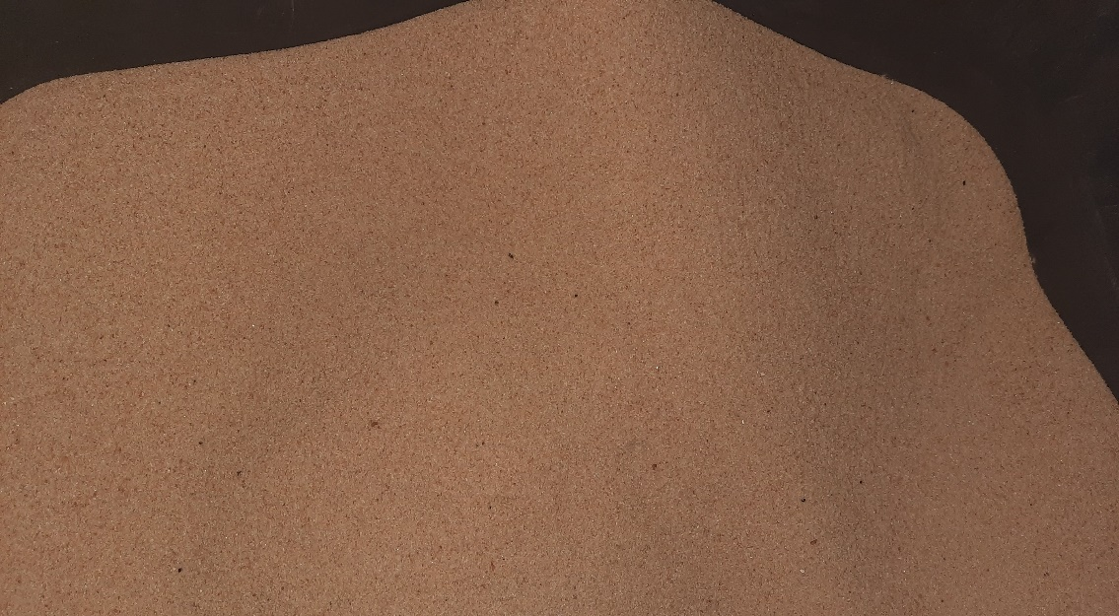

Soil sample 1:

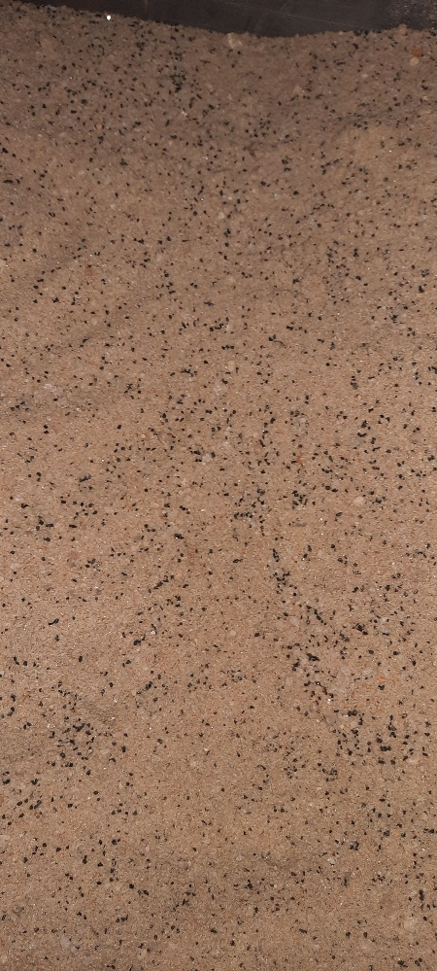

Soil sample 2:

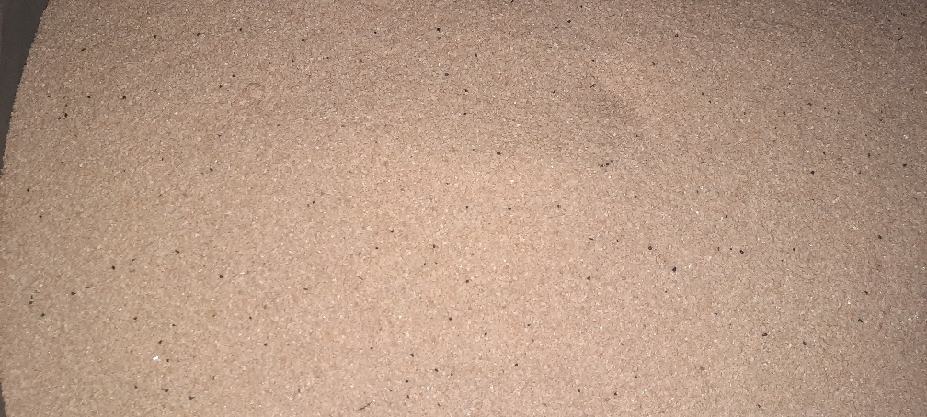

Soil sample 3:

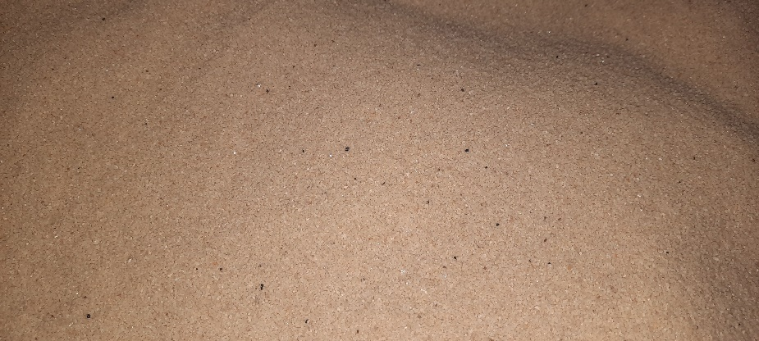

Soil sample 4:

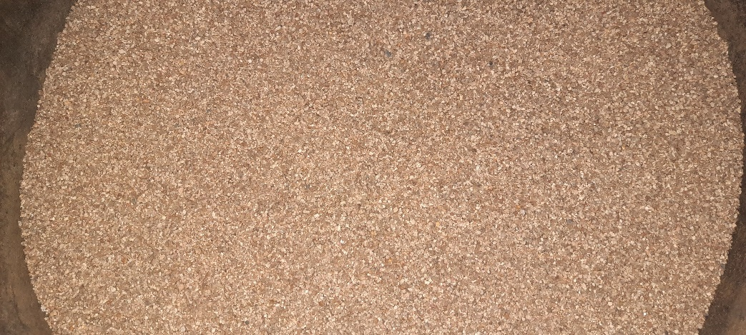

Soil sample 5:



Soil sample 6:

## Sieve analysis recoded data

|  |  |  |  |  |  |  |  |  |  |  |  |  |  |  |  |  |  |  |  |  |  |  |  |  |  |  |  |
| --- | --- | --- | --- | --- | --- | --- | --- | --- | --- | --- | --- | --- | --- | --- | --- | --- | --- | --- | --- | --- | --- | --- | --- | --- | --- | --- | --- |
| SOIL SAMPLE # 1 | | | | | | | | | | | | | | | | | | | | | | | | | | | |
| Sieve # | | | | | **Sieve Size (mm)** | | | | **Weight Retained (g)** | | | | | **% Retained** | | | | | **Cumulative Weight Retained (g)** | | | | | **% Passing** | | | |
|  | | | | |  | | | | C | | | | | D | | | | | E | | | | | F | | | |
|  | | | | |  | | | | 220,3 | | | | | D=(C/Total weight)*100 | | | | | E=D+E(i-1) | | | | | F=100-E | | | |
| 4 | | | | | 4,75 | | | | 0 | | | | | 0,00 | | | | | 0,00 | | | | | 100,00 | | | |
| 10 | | | | | 2 | | | | 0 | | | | | 0,00 | | | | | 0,00 | | | | | 100,00 | | | |
| 20 | | | | | 1,18 | | | | 0 | | | | | 0,00 | | | | | 0,00 | | | | | 100,00 | | | |
| 40 | | | | | 0,6 | | | | 34,1 | | | | | 15,48 | | | | | 15,48 | | | | | 84,52 | | | |
| 60 | | | | | 0,425 | | | | 70 | | | | | 31,77 | | | | | 47,25 | | | | | 52,75 | | | |
| 100 | | | | | 0,15 | | | | 107 | | | | | 48,57 | | | | | 95,82 | | | | | 4,18 | | | |
| 200 | | | | | 0,075 | | | | 8,1 | | | | | 3,68 | | | | | 99,50 | | | | | 0,50 | | | |
| Pan | | | | |  | | | | 1,1 | | | | | 0,50 | | | | | 100,00 | | | | | 0,00 | | | |
| Total weight = | | | | | | | | | 220,3 | | | | |  | | | | | 258,06 | | | | |  | | | |
|  | | | | | **finest modulus** | | | | 2,58 | | | | | **FINE SAND** | | | | |  | | | | |  | | | |
| SOIL SAMPLE #2 | | | | | | | | | | | | | | | | | | | | | | | | | | |
| Sieve # | | **Sieve Size (mm)** | | | | | **Weight Retained (g)** | | | | | **% Retained** | | | | | | **Cumulative Weight Retained (g)** | | | | | **% Passing** | | | |
|  | |  | | | | | C | | | | | D | | | | | | E | | | | | F | | | |
|  | |  | | | | | 300 | | | | | D=(C/Total weight)*100 | | | | | | E=D+E(i-1) | | | | | F=100-E | | | |
| 4 | | 4,75 | | | | | 0 | | | | | 0,00 | | | | | | 0,00 | | | | | 100,00 | | | |
| 10 | | 2 | | | | | 55,8 | | | | | 18,74 | | | | | | 18,74 | | | | | 81,26 | | | |
| 20 | | 1,18 | | | | | 98,1 | | | | | 32,94 | | | | | | 51,68 | | | | | 48,32 | | | |
| 40 | | 0,6 | | | | | 28 | | | | | 9,40 | | | | | | 61,08 | | | | | 38,92 | | | |
| 60 | | 0,425 | | | | | 18,9 | | | | | 6,35 | | | | | | 67,43 | | | | | 32,57 | | | |
| 100 | | 0,15 | | | | | 90,8 | | | | | 30,49 | | | | | | 97,92 | | | | | 2,08 | | | |
| 200 | | 0,075 | | | | | 4,1 | | | | | 1,38 | | | | | | 99,29 | | | | | 0,71 | | | |
| Pan | |  | | | | | 2,1 | | | | | 0,71 | | | | | | 100,00 | | | | | 0,00 | | | |
| Total weight = | | | | | | | 297,8 | | | | |  | | | | | | 296,84 | | | | |  | | | |
|  | | **finest modulus** | | | | | 2,97 | | | | | **COARSE SAND** | | | | | |  | | | | |  | | | |
| SOIL SAMPLE #3 | | | | | | | | | | | | | | | | | | | | | | | | | | | | |
| Sieve # | | | | **Sieve Size (mm)** | | | | | | **Weight Retained (g)** | | | | | **% Retained** | | | | | **Cumulative Weight Retained (g)** | | | | | **% Passing** | | | |
|  | | | |  | | | | | | C | | | | | D | | | | | E | | | | | F | | | |
|  | | | |  | | | | | | 220 | | | | | D=(C/Total weight)*100 | | | | | E=D+E(i-1) | | | | | F=100-E | | | |
| 4 | | | | 4,75 | | | | | | 0 | | | | | 0,00 | | | | | 0,00 | | | | | 100,00 | | | |
| 10 | | | | 2 | | | | | | 0 | | | | | 0,00 | | | | | 0,00 | | | | | 100,00 | | | |
| 20 | | | | 1,18 | | | | | | 5,7 | | | | | 2,59 | | | | | 2,59 | | | | | 97,41 | | | |
| 40 | | | | 0,6 | | | | | | 143,4 | | | | | 65,18 | | | | | 67,77 | | | | | 32,23 | | | |
| 60 | | | | 0,425 | | | | | | 37,1 | | | | | 16,86 | | | | | 84,64 | | | | | 15,36 | | | |
| 100 | | | | 0,15 | | | | | | 33,7 | | | | | 15,32 | | | | | 99,95 | | | | | 0,05 | | | |
| 200 | | | | 0,075 | | | | | | 0,1 | | | | | 0,05 | | | | | 100,00 | | | | | 0,00 | | | |
| Pan | | | |  | | | | | | 0 | | | | | 0,00 | | | | | 100,00 | | | | | 0,00 | | | |
| Total weight = | | | | | | | | | | 220 | | | | |  | | | | | 254,95 | | | | |  | | | |
|  | | | | **finest modulus** | | | | | | 2,55 | | | | | **FINE SAND** | | | | |  | | | | |  | | | |
| SOIL SAMPLE #4 | | | | | | | | | | | | | | | | | | | | | | | | | | |
| Sieve # | | | **Sieve Size (mm)** | | | | | **Weight Retained (g)** | | | | | **% Retained** | | | | **Cumulative Weight Retained (g)** | | | | | **% Passing** | | | | |
|  | | |  | | | | | C | | | | | D | | | | E | | | | | F | | | | |
|  | | |  | | | | | 220 | | | | | D=(C/Total weight)*100 | | | | E=D+E(i-1) | | | | | F=100-E | | | | |
| 4 | | | 4,75 | | | | | 0 | | | | | 0,00 | | | | 0,00 | | | | | 100,00 | | | | |
| 10 | | | 2 | | | | | 0 | | | | | 0,00 | | | | 0,00 | | | | | 100,00 | | | | |
| 20 | | | 1,18 | | | | | 4,1 | | | | | 1,87 | | | | 1,87 | | | | | 98,13 | | | | |
| 40 | | | 0,6 | | | | | 182,4 | | | | | 83,02 | | | | 84,89 | | | | | 15,11 | | | | |
| 60 | | | 0,425 | | | | | 13,8 | | | | | 6,28 | | | | 91,17 | | | | | 8,83 | | | | |
| 100 | | | 0,15 | | | | | 19,4 | | | | | 8,83 | | | | 100,00 | | | | | 0,00 | | | | |
| 200 | | | 0,075 | | | | | 0 | | | | | 0,00 | | | | 100,00 | | | | | 0,00 | | | | |
| Pan | | |  | | | | | 0 | | | | | 0,00 | | | | 100,00 | | | | | 0,00 | | | | |
| Total weight = | | | | | | | | 219,7 | | | | |  | | | | 277,92 | | | | |  | | | | |
|  | | | **finest modulus** | | | | | 2,78 | | | | | **MEDIUM SAND** | | | | | | | | |  | | | | |
| SOIL SAMPLE #5 | | | | | | | | | | | | | | | | | | | | | | | | | |
| Sieve # | **Sieve Size (mm)** | | | | | **Weight Retained (g)** | | | | | **% Retained** | | | | | **Cumulative Weight Retained (g)** | | | | | **% Passing** | | | | |
|  |  | | | | | C | | | | | D | | | | | E | | | | | F | | | | |
|  |  | | | | | 300 | | | | | D=(C/Total weight)*100 | | | | | E=D+E(i-1) | | | | | F=100-E | | | | |
| 4 | 4,75 | | | | | 0 | | | | | 0,00 | | | | | 0,00 | | | | | 100,00 | | | | |
| 10 | 2 | | | | | 19,7 | | | | | 6,63 | | | | | 6,63 | | | | | 93,37 | | | | |
| 20 | 1,18 | | | | | 105,9 | | | | | 35,66 | | | | | 42,29 | | | | | 57,71 | | | | |
| 40 | 0,6 | | | | | 130,8 | | | | | 44,04 | | | | | 86,33 | | | | | 13,67 | | | | |
| 60 | 0,425 | | | | | 34,3 | | | | | 11,55 | | | | | 97,88 | | | | | 2,12 | | | | |
| 100 | 0,15 | | | | | 6,2 | | | | | 2,09 | | | | | 99,97 | | | | | 0,03 | | | | |
| 200 | 0,075 | | | | | 0,1 | | | | | 0,03 | | | | | 100,00 | | | | | 0,00 | | | | |
| Pan |  | | | | | 0 | | | | | 0,00 | | | | | 100,00 | | | | | 0,00 | | | | |
| Total weight = | | | | | | 297 | | | | |  | | | | | 333,10 | | | | |  | | | | |
|  | **finest modulus** | | | | | 3,33 | | | | | **COARSE SAND** | | | | |  | | | | |  | | | | |
| SOIL SAMPLE #6 | | | | | | | | | | | | | | | | | | | | | | | | | | |
| Sieve # | | | **Sieve Size (mm)** | | | | | **Weight Retained (g)** | | | | | **% Retained** | | | | **Cumulative Weight Retained (g)** | | | | | **% Passing** | | | | |
|  | | |  | | | | | C | | | | | D | | | | E | | | | | F | | | | |
|  | | |  | | | | | 300 | | | | | D=(C/Total weight)*100 | | | | E=D+E(i-1) | | | | | F=100-E | | | | |
| 4 | | | 4,75 | | | | | 0 | | | | | 0,00 | | | | 0,00 | | | | | 100,00 | | | | |
| 10 | | | 2 | | | | | 2,3 | | | | | 0,77 | | | | 0,77 | | | | | 99,23 | | | | |
| 20 | | | 1,18 | | | | | 59,1 | | | | | 19,79 | | | | 20,56 | | | | | 79,44 | | | | |
| 40 | | | 0,6 | | | | | 72,2 | | | | | 24,18 | | | | 44,74 | | | | | 55,26 | | | | |
| 60 | | | 0,425 | | | | | 70,3 | | | | | 23,54 | | | | 68,29 | | | | | 31,71 | | | | |
| 100 | | | 0,15 | | | | | 56,8 | | | | | 19,02 | | | | 87,31 | | | | | 12,69 | | | | |
| 200 | | | 0,075 | | | | | 27,1 | | | | | 9,08 | | | | 96,38 | | | | | 3,62 | | | | |
| Pan | | |  | | | | | 10,8 | | | | | 3,62 | | | | 100,00 | | | | | 0,00 | | | | |
| Total weight = | | | | | | | | 298,6 | | | | |  | | | | 221,67 | | | | |  | | | | |
|  | | | **finest modulus** | | | | | 2,22 | | | | | **FINE SAND** | | | |  | | | | |  | | | | |

## Recorded depth of scouring

**Soil sample 1:**

|  |  |  |  |  |  |  |
| --- | --- | --- | --- | --- | --- | --- |
| **Pier shape** | **Soil type** | **Mitigation** | **Water Depth (mm)** | **Flow rate(m3/h)** | **Depth(mm) after 2min** | **depth** |
| **Circular** | Fine |  | **0** | **0** | **0** | **0** |
|  |  | None | 11,69 | 3,96 | -7,59 | 7,59 |
|  |  | None | 15,06 | 6,3 | -16,66 | 16,66 |
|  |  | None | 16,03 | 9,45 | -35,52 | 35,52 |
|  |  | None | 17,66 | **12,96** | -43,35 | **43,35** |
|  |  | Riprap | 18,38 | **13,03** | -17,98 | **17,98** |
| **Lenticular** | Fine |  | 0 | **0** | 0 | **0** |
|  |  | None | 8,19 | 3,82 | -0,66 | 0,66 |
|  |  | None | 7 | 6,77 | -13,86 | 13,86 |
|  |  | None | 10,43 | 9,86 | -19,42 | 19,42 |
|  |  | None | 12,85 | **12,8** | -18,59 | **18,59** |
|  |  | Riprap | 18,79 | **12,71** | -7,17 | **7,17** |
| **Joukowsky** | Fine |  | 0 | **0** | 0 | **0** |
|  |  | None | 6,33 | 3,25 | -16,09 | 16,09 |
|  |  | None | 7,29 | 6,5 | -25,42 | 25,42 |
|  |  | None | 10,47 | 9,5 | -27,46 | 27,46 |
|  |  | None | 15,26 | **12,8** | -28,79 | **28,79** |
|  |  | Riprap | 21,84 | **13,04** | -3,49 | **3,49** |
| **Oblong** | Fine |  | 0 | **0** | 0 | **0** |
|  |  | None | 9,97 | 3,43 | -16,97 | 16,97 |
|  |  | None | 12,56 | 6,17 | -26,76 | 26,76 |
|  |  | None | 14,89 | 9,05 | -35,23 | 35,23 |
|  |  | None | 17,97 | **12,85** | -38,88 | **38,88** |
|  |  | Riprap | 21,23 | **12,9** | -10,44 | **10,44** |
| **Rectangular** | Fine |  | 0 | **0** | 0 | **0** |
|  |  | None | 10 | 3,49 | -9,83 | 9,83 |
|  |  | None | 13,35 | 6,17 | -23,04 | 23,04 |
|  |  | None | 15,97 | 9,32 | -36,9 | 36,9 |
|  |  | None | 13,05 | **12,25** | -42,53 | **42,53** |
|  |  | Riprap | 22,23 | **12,3** | -1,55 | **1,55** |

**Soil sample 2:**

|  |  |  |  |  |  |  |
| --- | --- | --- | --- | --- | --- | --- |
| **Pier shape** | **Soil type** | **Mitigation** | **Water Depth (mm)** | **Flow rate(m3/h)** | **Depth(mm) after 2min** | **depth** |
| **Circular** | course |  | **0** | **0** | **0** | **0** |
|  |  | None | 9,47 | 2,89 | -0,24 | 0,24 |
|  |  | None | 14,86 | 5,47 | -5,03 | 5,03 |
|  |  | None | 19,74 | 9,11 | -9,59 | 9,59 |
|  |  | None | 23,17 | **12,9** | -27,89 | **27,89** |
|  |  | Riprap | 25,4 | **12,97** | -4,8 | **4,8** |
| **Lenticular** | course |  | 0 | **0** | 0 | **0** |
|  |  | None | 9,67 | 3,35 | -0,44 | 0,44 |
|  |  | None | 13,35 | 6,66 | -1,4 | 1,4 |
|  |  | None | 14 | 9,83 | -5,82 | 5,82 |
|  |  | None | 16,9 | **12,8** | -11,96 | **11,96** |
|  |  | Riprap | 19,28 | **13** | -13,86 | **13,86** |
| **Joukowsky** | course |  | 0 | **0** | 0 | **0** |
|  |  | None | 12,13 | 3,76 | -0,05 | 0,05 |
|  |  | None | 15,66 | 6,1 | -0,15 | 0,15 |
|  |  | None | 17,14 | 9,05 | -8,73 | 8,73 |
|  |  | None | 21,44 | **12,95** | -17,95 | **17,95** |
|  |  | Riprap | 21,95 | **12,9** | -12,77 | **12,77** |
| **Oblong** | course |  | 0 | **0** | 0 | **0** |
|  |  | None | 8,61 | 3,35 | -6,87 | 6,87 |
|  |  | None | 11,29 | 6,05 | -17,98 | 17,98 |
|  |  | None | 15,07 | 9,97 | -24,96 | 24,96 |
|  |  | None | 18,06 | **12,93** | -32,9 | **32,9** |
|  |  | Riprap | 21,62 | **12,9** | -0,58 | **0,58** |
| **Rectangular** | course |  | 0 | **0** | 0 | **0** |
|  |  | None | 8,03 | 3,83 | -8,87 | 8,87 |
|  |  | None | 11,78 | 6,75 | -22,4 | 22,4 |
|  |  | None | 14,05 | 9,15 | -23,8 | 23,8 |
|  |  | None | 14,73 | **12,95** | -33,8 | **33,8** |
|  |  | Riprap | 21,69 | **12,91** | -10,26 | **10,26** |

**Soil sample 3:**

|  |  |  |  |  |  |  |
| --- | --- | --- | --- | --- | --- | --- |
| **Pier shape** | **Soil type** | **Mitigation** | **Water Depth (mm)** | **Flow rate(m3/h)** | **Depth(mm) after 2min** | **depth** |
| **Circular** | fine |  | **0** | **0** | **0** | **0** |
|  |  | None | 8,86 | 3,57 | -2,28 | 2,28 |
|  |  | None | 10,54 | 6,29 | -19,93 | 19,93 |
|  |  | None | 14,68 | 9,67 | -32,68 | 32,68 |
|  |  | None | 15,37 | **12,95** | -37,71 | **37,71** |
|  |  | Riprap | 20,51 | **12,95** | -7,4 | **7,4** |
| **Lenticular** | fine |  | 0 | **0** | 0 | **0** |
|  |  | None | 4,4 | 3,54 | -1 | 1 |
|  |  | None | 7,74 | 6,13 | -4,33 | 4,33 |
|  |  | None | 11,79 | 10,12 | -12,49 | 12,49 |
|  |  | None | 12,71 | **12,85** | -14,07 | **14,07** |
|  |  | Riprap | 17,23 | **12,95** | -2,98 | **2,98** |
| **Joukowsky** | fine |  | 0 | **0** | 0 | **0** |
|  |  | None | 3,46 | 2,9 | -7,2 | 7,2 |
|  |  | None | 8,19 | 6,37 | -10,77 | 10,77 |
|  |  | None | 10,62 | 9,26 | -15,34 | 15,34 |
|  |  | None | 14,06 | **12,8** | -20,44 | **20,44** |
|  |  | Riprap | 19,34 | **12,85** | -8,98 | **8,98** |
| **Oblong** | fine |  | 0 | **0** | 0 | **0** |
|  |  | None | 5,03 | 3,09 | -22,38 | 22,38 |
|  |  | None | 8,58 | 6,18 | -27,18 | 27,18 |
|  |  | None | 12,18 | 9,5 | -36,25 | 36,25 |
|  |  | None | 15,87 | **12,8** | -40,61 | **40,61** |
|  |  | Riprap | 21,86 | **12,85** | -2,53 | **2,53** |
| **Rectangular** | fine |  | 0 | **0** | 0 | **0** |
|  |  | None | 9,36 | 3,4 | -17,16 | 17,16 |
|  |  | None | 11,95 | 6,52 | -32,02 | 32,02 |
|  |  | None | 15,47 | 9,12 | -37,9 | 37,9 |
|  |  | None | 17,64 | **12,92** | -40,63 | **40,63** |
|  |  | Riprap | 21,77 | **12,85** | -8,6 | **8,6** |

**Soil sample 4:**

|  |  |  |  |  |  |  |
| --- | --- | --- | --- | --- | --- | --- |
| **Pier shape** | **Soil type** | **Mitigation** | **Water Depth (mm)** | **Flow rate(m3/h)** | **Depth(mm) after 2min** | **depth** |
| **Circular** | medium |  | **0** | **0** | **0** | **0** |
|  |  | None | 9,4 | 2,46 | -5,39 | 5,39 |
|  |  | None | 14,93 | 5,37 | -24,03 | 24,03 |
|  |  | None | 19,1 | 8 | -30,98 | 30,98 |
|  |  | None | 25,39 | **13** | -39,32 | **39,32** |
|  |  | Riprap | 25,39 | **13** | -8,97 | **8,97** |
| **Lenticular** | medium |  | 0 | **0** | 0 | **0** |
|  |  | None | 8,71 | 2,75 | 0 | 0 |
|  |  | None | 11,88 | 5,77 | -1,09 | 1,09 |
|  |  | None | 14,39 | 8,44 | -3,8 | 3,8 |
|  |  | None | 18,67 | **12,91** | -17,9 | **17,9** |
|  |  | Riprap | 25,66 | **12,91** | -4,18 | **4,18** |
| **Joukowsky** | medium |  | 0 | **0** | 0 | **0** |
|  |  | None | 12,55 | 2,81 | -2,15 | 2,15 |
|  |  | None | 17,04 | 5,04 | -3,35 | 3,35 |
|  |  | None | 21,01 | 8,48 | -8,89 | 8,89 |
|  |  | None | 27,67 | **12,93** | -20,12 | **20,12** |
|  |  | Riprap | 19,65 | **13,12** | -27,04 | **27,04** |
| **Oblong** | medium |  | 0 | **0** | 0 | **0** |
|  |  | None | 7,65 | 2,86 | -17,92 | 17,92 |
|  |  | None | 10,33 | 5,61 | -25,75 | 25,75 |
|  |  | None | 13,98 | 8,21 | -30,81 | 30,81 |
|  |  | None | 19,81 | **12,87** | -35,27 | **35,27** |
|  |  | Riprap | 19,88 | **13** | -9,02 | **9,02** |
| **Rectangular** | medium |  | 0 | **0** | 0 | **0** |
|  |  | None | 15,91 | 4,5 | -19,32 | 19,32 |
|  |  | None | 18,02 | 6,6 | -27,95 | 27,95 |
|  |  | None | 20,39 | 9,65 | -35,5 | 35,5 |
|  |  | None | 23,75 | **13,03** | -41,24 | **41,24** |
|  |  | Riprap | 20,95 | **12,97** | -13,33 | **13,33** |

**Soil sample 5:**

|  |  |  |  |  |  |  |
| --- | --- | --- | --- | --- | --- | --- |
| **Pier shape** | **Soil type** | **Mitigation** | **Water Depth (mm)** | **Flow rate(m3/h)** | **Depth(mm) after 2min** | **depth** |
| **Circular** | course |  | **0** | **0** | **0** |  |
|  |  | None | 10,1 | 3,44 | -1,5 | 1,5 |
|  |  | None | 9,48 | 6,84 | -24,72 | 24,72 |
|  |  | None | 10,05 | 9,66 | -31,94 | 31,94 |
|  |  | None | 11,12 | **12,8** | -39,1 | **39,1** |
|  |  | Riprap | 15,34 | **12,8** | -12,51 | **12,51** |
| **Lenticular** | course |  | 0 | **0** | 0 | **0** |
|  |  | None | 7,56 | 3,53 | -0,31 | 0,31 |
|  |  | None | 10,53 | 6,37 | 1,53 | 1,53 |
|  |  | None | 12,68 | 9,06 | 1,6 | 1,6 |
|  |  | None | 15,4 | **12,7** | -1,21 | **1,21** |
|  |  | Riprap | 20 | **12,95** | -4,68 | **4,68** |
| **Joukowsky** | course |  | 0 | **0** | 0 | **0** |
|  |  | None | 9,31 | 3,09 | -0,26 | 0,26 |
|  |  | None | 12,67 | 6,35 | -14,44 | 14,44 |
|  |  | None | 13,01 | 9,4 | -17,64 | 17,64 |
|  |  | None | 17,14 | **12,8** | -20,68 | **20,68** |
|  |  | Riprap | 21,25 | **12,8** | -1,53 | **1,53** |
| **Oblong** | course |  | 0 | **0** | 0 | **0** |
|  |  | None | 11,84 | 3,4 | -0,12 | 0,12 |
|  |  | None | 16,16 | 6,25 | -0,37 | 0,37 |
|  |  | None | 18,63 | 9,67 | -14,91 | 14,91 |
|  |  | None | 18,99 | **12,8** | -34,97 | **34,97** |
|  |  | Riprap | 20,85 | **12,8** | -3,63 | **3,63** |
| **Rectangular** | course |  | 0 | **0** | 0 | **0** |
|  |  | None | 8,88 | 3,47 | -0,49 | 0,49 |
|  |  | None | 12,41 | 6,42 | -17,29 | 17,29 |
|  |  | None | 14,42 | 9,5 | -40,44 | 40,44 |
|  |  | None | 17,04 | **12,9** | -50,9 | **50,9** |
|  |  | Riprap | 29,94 | **12,83** | -1,88 | **1,88** |

**Soil sample 6:**

|  |  |  |  |  |  |  |
| --- | --- | --- | --- | --- | --- | --- |
| **Pier shape** | **Soil type** | **Mitigation** | **Water Depth (mm)** | **Flow rate(m3/h)** | **Depth(mm) after 2min** | **depth** |
| **Circular** | Fine | None | **0** | **0** | **0** | **0** |
|  |  | None | 5,21 | 2,56 | 0 | 0 |
|  |  | None | 14,78 | 6,01 | -9,7 | 9,7 |
|  |  | None | 19,05 | 9,13 | -27,26 | 27,26 |
|  |  | None | 22,11 | 13,05 | -35,82 | **35,82** |
|  |  | Riprap | 22,4 | 13,02 | -2,41 | **2,41** |
| **Lenticular** | Fine | None | 0 | 0 | 0 | **0** |
|  |  | None | 6,95 | 2,87 | 0 | 0 |
|  |  | None | 12,7 | 6,28 | 1,09 | 1,09 |
|  |  | None | 14,31 | 9,32 | -0,38 | 0,38 |
|  |  | None | 16,1 | 13 | -4,01 | **4,01** |
|  |  | Riprap | 21,74 | 13,07 | 0,28 | **0,28** |
| **Joukowsky** | Fine | None | 0 | 0 | 0 | **0** |
|  |  | None | 6,31 | 3,05 | 0 | 0 |
|  |  | None | 10,78 | 6,55 | -16,05 | 16,05 |
|  |  | None | 12,98 | 9,7 | -22,42 | 22,42 |
|  |  | None | 16,32 | 12,9 | -27,11 | **27,11** |
|  |  | Riprap | 22,46 | 12,9 | -6,25 | **6,25** |
| **Oblong** | Fine | None | 0 | 0 | 0 | **0** |
|  |  | None | 10,24 | 3,33 | 0,77 | 0,77 |
|  |  | None | 14,07 | 6,7 | -7,41 | 7,41 |
|  |  | None | 16,5 | 9,45 | -22,3 | 22,3 |
|  |  | None | 18,81 | 13,01 | -35,61 | **35,61** |
|  |  | Riprap | 24,49 | 13,05 | -5,34 | **5,34** |
| **Rectangular** | Fine | None | 0 | 0 | 0 | **0** |
|  |  | None | 8,44 | 3,15 | -8,16 | 8,16 |
|  |  | None | 12,78 | 6,6 | -13,72 | 13,72 |
|  |  | None | 16,2 | 9,15 | -21,3 | 21,3 |
|  |  | None | 20,11 | 12,95 | -39,11 | **39,11** |
|  |  | Riprap | 19,98 | 13,03 | -1,02 | **1,02** |

## Table with percentage effect of rip-rap

|  |  |  |  |  |  |  |  |  |  |  |  |  |  |  |  |  |
| --- | --- | --- | --- | --- | --- | --- | --- | --- | --- | --- | --- | --- | --- | --- | --- | --- |
| **SOIL SAMPLE 1** | | | | | | | | | | | | | | | | |
| **the effect of rip-rap** |  | | **Circular** | | | | **Lenticular** | | | **Joukowsky** | | **Oblong** | | | **Rectangular** | |
| **without** | **Flow rate(m3/h)** | | 12,96 | | | | 12,8 | | | 12,8 | | 12,85 | | | 12,25 | |
| **scour depth** | | 43,35 | | | | 18,59 | | | 28,79 | | 38,88 | | | 42,53 | |
| **with rip-rap** | **Flow rate(m3/h)** | | 13,03 | | | | 12,71 | | | 13,04 | | 12,9 | | | 12,3 | |
| **scour depth** | | 17,98 | | | | 7,17 | | | 3,49 | | 10,44 | | | 1,55 | |
| %Error between flow rates |  | | 0,54 | | | | 0,71 | | | 1,84 | | 0,39 | | | 0,41 | |
| **% effect of rip-rap** |  | | 58,52 | | | | 61,43 | | | 87,88 | | 73,15 | | | 96,36 | |
| **SOIL SAMPLE 2** | | | | | | | | | | | | | | | | |
| **the effect of rip-rap** |  | | **Circular** | | | | **Lenticular** | | | **Joukowsky** | | **Oblong** | | | | **Rectangular** |
| **without** | **Flow rate(m3/h)** | | 12,9 | | | | 12,8 | | | 12,95 | | 12,93 | | | | 12,95 |
| **scour depth** | | 27,89 | | | | 11,96 | | | 17,95 | | 32,9 | | | | 33,8 |
| **with rip-rap** | **Flow rate(m3/h)** | | 12,97 | | | | 13 | | | 12,9 | | 12,9 | | | | 12,91 |
| **scour depth** | | 4,8 | | | | 13,86 | | | 12,77 | | 0,58 | | | | 10,26 |
| %Error between flow rates |  | | 0,54 | | | | 1,54 | | | 0,39 | | 0,23 | | | | 0,31 |
| **% effect of rip-rap** |  | | 82,79 | | | | -15,89 | | | 28,86 | | 98,24 | | | | 69,64 |
| **SOIL SAMPLE 3** | | | | | | | | | | | | | | | | |
| **the effect of rip-rap** |  | | **Circular** | | | **Lenticular** | | | **Joukowsky** | | | **Oblong** | | | | **Rectangular** |
| **without** | **Flow rate(m3/h)** | | 12,95 | | | 12,85 | | | 12,8 | | | 12,8 | | | | 12,92 |
| **scour depth** | | 37,71 | | | 14,07 | | | 20,44 | | | 40,61 | | | | 40,63 |
| **with rip-rap** | **Flow rate(m3/h)** | | 12,95 | | | 12,95 | | | 12,85 | | | 12,85 | | | | 12,85 |
| **scour depth** | | 7,4 | | | 2,98 | | | 8,98 | | | 2,53 | | | | 8,6 |
| %Error between flow rates |  | | 0,00 | | | 0,77 | | | 0,39 | | | 0,39 | | | | 0,54 |
| **% effect of rip-rap** |  | | 80,38 | | | 78,82 | | | 56,07 | | | 93,77 | | | | 78,83 |
| **SOIL SAMPLE 4** | | | | | | | | | | | | | | | | |
| **the effect of rip-rip** |  | | | **Circular** | | | **Lenticular** | | | **Joukowsky** | | **Oblong** | | | | **Rectangular** |
| **without** | **Flow rate(m3/h)** | | | 13 | | | 12,91 | | | 12,93 | | 12,87 | | | | 13,03 |
| **scour depth** | | | 39,32 | | | 17,9 | | | 20,12 | | 35,27 | | | | 41,24 |
| **with rip-rap** | **Flow rate(m3/h)** | | | 13 | | | 12,91 | | | 13,12 | | 13 | | | | 12,97 |
| **scour depth** | | | 8,97 | | | 4,18 | | | 27,04 | | 9,02 | | | | 13,33 |
| %Error between flow rates |  | | | 0,00 | | | 0,00 | | | 1,45 | | 1,00 | | | | 0,46 |
| **% effect of rip-rap** |  | | | 77,19 | | | 76,65 | | | -34,39 | | 74,43 | | | | 67,68 |
| **SOIL SAMPLE 5** | | | | | | | | | | | | | | | | |
| **the effect of rip-rap** | |  | **Circular** | | | **Lenticular** | | | **Joukowsky** | | | | **Oblong** | | | **Rectangular** |
| **without** | | **Flow rate(m3/h)** | 12,8 | | | 12,7 | | | 12,8 | | | | 12,8 | | | 12,9 |
| **scour depth** | 39,1 | | | 1,21 | | | 20,68 | | | | 34,97 | | | 50,9 |
| **with rip-rap** | | **Flow rate(m3/h)** | 12,8 | | | 12,95 | | | 12,8 | | | | 12,8 | | | 12,83 |
| **scour depth** | 12,51 | | | 4,68 | | | 1,53 | | | | 3,63 | | | 1,88 |
| %Error between flow rates | |  | 0,00 | | | 1,93 | | | 0,00 | | | | 0,00 | | | 0,55 |
| **% effect of rip-rap** | |  | 68,01 | | | -286,78 | | | 92,60 | | | | 89,62 | | | 96,31 |
| **SOIL SAMPLE 6** | | | | | | | | | | | | | | | | |
| **the effect of rip-rap** |  | | **Circular** | | **Lenticular** | | | **Joukowsky** | | | **Oblong** | | | **Rectangular** | | |
| **without** | **Flow rate(m3/h)** | | 13,05 | | 13 | | | 12,9 | | | 13,01 | | | 12,95 | | |
| **scour depth** | | 35,82 | | 4,01 | | | 27,11 | | | 35,61 | | | 39,11 | | |
| **with rip-rap** | **Flow rate(m3/h)** | | 13,02 | | 13,07 | | | 12,9 | | | 13,05 | | | 13,03 | | |
| **scour depth** | | 2,41 | | 0,28 | | | 6,25 | | | 5,34 | | | 1,02 | | |
| %Error between flow rates |  | | 0,23 | | 0,54 | | | 0,00 | | | 0,31 | | | 0,61 | | |
| **% effect of rip-rap** |  | | 93,27 | | 93,02 | | | 76,95 | | | 85,00 | | | 97,39 | | |

## Tables with ds/D vs Re

**Soil sample 1:**

|  |  |  |  |  |  |  |  |  |  |  |  |  |  |  |  |  |
| --- | --- | --- | --- | --- | --- | --- | --- | --- | --- | --- | --- | --- | --- | --- | --- | --- |
| **Pier Shape** | **Mitigation** | **Water Depth (mm)** | **Flow rate(m3/h)** | | **Depth(mm) after 2min** | | **W(mm)** | | **D(mm)** | | **V(m/s)** | | **Re** | | **ds/D** | |
|  | None | 11,69 | | 3,96 | | -7,59 | | 600 | | 48 | | 0,16 | | 1 833 | | 0,16 |
| Circular | None | 15,06 | | 6,3 | | -16,66 | | 600 | | 48 | | 0,19 | | 2 917 | | 0,35 |
|  | None | 16,03 | | 9,45 | | -35,52 | | 600 | | 48 | | 0,27 | | 4 375 | | 0,74 |
|  | None | 17,66 | | 12,96 | | -43,35 | | 600 | | 48 | | 0,34 | | 6 000 | | 0,90 |
|  | Riprap | 18,38 | | 13,03 | | -17,98 | | 600 | | 48 | | 0,33 | | 6 032 | | 0,37 |
| Lenticular | None | 8,19 | | 3,82 | | -0,66 | | 600 | | 46 | | 0,22 | | 1 769 | | 0,01 |
|  | None | 7 | | 6,77 | | -13,86 | | 600 | | 46 | | 0,45 | | 3 134 | | 0,30 |
|  | None | 10,43 | | 9,86 | | -19,42 | | 600 | | 46 | | 0,44 | | 4 565 | | 0,42 |
|  | None | 12,85 | | 12,8 | | -18,59 | | 600 | | 46 | | 0,46 | | 5 926 | | 0,40 |
|  | Riprap | 18,79 | | 12,71 | | -7,17 | | 600 | | 46 | | 0,31 | | 5 884 | | 0,16 |
| Joukowsky | None | 6,33 | | 3,25 | | -16,09 | | 600 | | 36 | | 0,24 | | 1 505 | | 0,45 |
|  | None | 7,29 | | 6,5 | | -25,42 | | 600 | | 36 | | 0,41 | | 3 009 | | 0,71 |
|  | None | 10,47 | | 9,5 | | -27,46 | | 600 | | 36 | | 0,42 | | 4 398 | | 0,76 |
|  | None | 15,26 | | 12,8 | | -28,79 | | 600 | | 36 | | 0,39 | | 5 926 | | 0,80 |
|  | Riprap | 21,84 | | 13,04 | | -3,49 | | 600 | | 36 | | 0,28 | | 6 037 | | 0,10 |
| Oblong | None | 9,97 | | 3,43 | | -16,97 | | 600 | | 48 | | 0,16 | | 1 588 | | 0,35 |
|  | None | 12,56 | | 6,17 | | -26,76 | | 600 | | 48 | | 0,23 | | 2 856 | | 0,56 |
|  | None | 14,89 | | 9,05 | | -35,23 | | 600 | | 48 | | 0,28 | | 4 190 | | 0,73 |
|  | None | 17,97 | | 12,85 | | -38,88 | | 600 | | 48 | | 0,33 | | 5 949 | | 0,81 |
|  | Riprap | 21,23 | | 12,9 | | -10,44 | | 600 | | 48 | | 0,28 | | 5 972 | | 0,22 |
| Rectangular | None | 10 | | 3,49 | | -9,83 | | 600 | | 48 | | 0,16 | | 1 616 | | 0,20 |
|  | None | 13,35 | | 6,17 | | -23,04 | | 600 | | 48 | | 0,21 | | 2 856 | | 0,48 |
|  | None | 15,97 | | 9,32 | | -36,9 | | 600 | | 48 | | 0,27 | | 4 315 | | 0,77 |
|  | None | 13,05 | | 12,25 | | -42,53 | | 600 | | 48 | | 0,43 | | 5 671 | | 0,89 |
|  | Riprap | 22,23 | | 12,3 | | -1,55 | | 600 | | 48 | | 0,26 | | 5 694 | | 0,03 |

**Soil sample 2:**

|  |  |  |  |  |  |  |  |  |  |
| --- | --- | --- | --- | --- | --- | --- | --- | --- | --- |
| **Pier Shape** | **Mitigation** | **Water Depth (mm)** | **Flow rate(m3/h)** | **Depth(mm) after 2min** | **W(mm)** | **D(mm)** | **V(m/s)** | **Re** | **ds/D** |
|  | None | 9,47 | 2,89 | -0,24 | 600 | 48 | 0,141 | 1338 | 0,005 |
| Circular | None | 14,86 | 5,47 | -5,03 | 600 | 48 | 0,170 | 2532 | 0,105 |
|  | None | 19,74 | 9,11 | -9,59 | 600 | 48 | 0,214 | 4218 | 0,200 |
|  | None | 23,17 | 12,9 | -27,89 | 600 | 48 | 0,258 | 5972 | 0,581 |
|  | Riprap | 25,4 | 12,97 | -4,8 | 600 | 48 | 0,236 | 6005 | 0,100 |
| Lenticular | None | 9,67 | 3,35 | -0,44 | 600 | 46 | 0,160 | 1551 | 0,010 |
|  | None | 13,35 | 6,66 | -1,4 | 600 | 46 | 0,231 | 3083 | 0,030 |
|  | None | 14 | 9,83 | -5,82 | 600 | 46 | 0,325 | 4551 | 0,127 |
|  | None | 16,9 | 12,8 | -11,96 | 600 | 46 | 0,351 | 5926 | 0,260 |
|  | Riprap | 19,28 | 13 | -13,86 | 600 | 46 | 0,312 | 6019 | 0,301 |
| Joukowsky | None | 12,13 | 3,76 | -0,05 | 600 | 36 | 0,144 | 1741 | 0,001 |
|  | None | 15,66 | 6,1 | -0,15 | 600 | 36 | 0,180 | 2824 | 0,004 |
|  | None | 17,14 | 9,05 | -8,73 | 600 | 36 | 0,244 | 4190 | 0,243 |
|  | None | 21,44 | 12,95 | -17,95 | 600 | 36 | 0,280 | 5995 | 0,499 |
|  | Riprap | 21,95 | 12,9 | -12,77 | 600 | 36 | 0,272 | 5972 | 0,355 |
| Oblong | None | 8,61 | 3,35 | -6,87 | 600 | 48 | 0,180 | 1551 | 0,143 |
|  | None | 11,29 | 6,05 | -17,98 | 600 | 48 | 0,248 | 2801 | 0,375 |
|  | None | 15,07 | 9,97 | -24,96 | 600 | 48 | 0,306 | 4616 | 0,520 |
|  | None | 18,06 | 12,93 | -32,9 | 600 | 48 | 0,331 | 5986 | 0,685 |
|  | Riprap | 21,62 | 12,9 | -0,58 | 600 | 48 | 0,276 | 5972 | 0,012 |
| Rectangular | None | 8,03 | 3,83 | -8,87 | 600 | 48 | 0,221 | 1773 | 0,185 |
|  | None | 11,78 | 6,75 | -22,4 | 600 | 48 | 0,265 | 3125 | 0,467 |
|  | None | 14,05 | 9,15 | -23,8 | 600 | 48 | 0,302 | 4236 | 0,496 |
|  | None | 14,73 | 12,95 | -33,8 | 600 | 48 | 0,407 | 5995 | 0,704 |
|  | Riprap | 21,69 | 12,91 | -10,26 | 600 | 48 | 0,276 | 5977 | 0,214 |

**Soil sample 3:**

|  |  |  |  |  |  |  |  |  |  |
| --- | --- | --- | --- | --- | --- | --- | --- | --- | --- |
| **pier shapes** | **Mitigation** | **Water Depth (mm)** | **Flow rate(m3/h)** | **Depth(mm) after 2min** | **W(mm)** | **D(mm)** | **V(m/s)** | **Re** | **ds/D** |
|  | None | 8,86 | 3,57 | -2,28 | 600 | 48 | 0,187 | 1 653 | 0,048 |
| Circular | None | 10,54 | 6,29 | -19,93 | 600 | 48 | 0,276 | 2 912 | 0,415 |
|  | None | 14,68 | 9,67 | -32,68 | 600 | 48 | 0,305 | 4 477 | 0,681 |
|  | None | 15,37 | 12,95 | -37,71 | 600 | 48 | 0,390 | 5 995 | 0,786 |
|  | Riprap | 20,51 | 12,95 | -7,4 | 600 | 48 | 0,292 | 5 995 | 0,154 |
| Eliptical | None | 4,4 | 3,54 | -1 | 600 | 46 | 0,372 | 1 639 | 0,022 |
|  | None | 7,74 | 6,13 | -4,33 | 600 | 46 | 0,367 | 2 838 | 0,094 |
|  | None | 11,79 | 10,12 | -12,49 | 600 | 46 | 0,397 | 4 685 | 0,272 |
|  | None | 12,71 | 12,85 | -14,07 | 600 | 46 | 0,468 | 5 949 | 0,306 |
|  | Riprap | 17,23 | 12,95 | -2,98 | 600 | 46 | 0,348 | 5 995 | 0,065 |
| Joukowsky | None | 3,46 | 2,9 | -7,2 | 600 | 36 | 0,388 | 1 343 | 0,200 |
|  | None | 8,19 | 6,37 | -10,77 | 600 | 36 | 0,360 | 2 949 | 0,299 |
|  | None | 10,62 | 9,26 | -15,34 | 600 | 36 | 0,404 | 4 287 | 0,426 |
|  | None | 14,06 | 12,8 | -20,44 | 600 | 36 | 0,421 | 5 926 | 0,568 |
|  | Riprap | 19,34 | 12,85 | -8,98 | 600 | 36 | 0,308 | 5 949 | 0,249 |
| Oblong | None | 5,03 | 3,09 | -22,38 | 600 | 48 | 0,284 | 1 431 | 0,466 |
|  | None | 8,58 | 6,18 | -27,18 | 600 | 48 | 0,333 | 2 861 | 0,566 |
|  | None | 12,18 | 9,5 | -36,25 | 600 | 48 | 0,361 | 4 398 | 0,755 |
|  | None | 15,87 | 12,8 | -40,61 | 600 | 48 | 0,373 | 5 926 | 0,846 |
|  | Riprap | 21,86 | 12,85 | -2,53 | 600 | 48 | 0,272 | 5 949 | 0,053 |
| Rectangular | None | 9,36 | 3,4 | -17,16 | 600 | 48 | 0,168 | 1 574 | 0,358 |
|  | None | 11,95 | 6,52 | -32,02 | 600 | 48 | 0,253 | 3 019 | 0,667 |
|  | None | 15,47 | 9,12 | -37,9 | 600 | 48 | 0,273 | 4 222 | 0,790 |
|  | None | 17,64 | 12,92 | -40,63 | 600 | 48 | 0,339 | 5 981 | 0,846 |
|  | Riprap | 21,77 | 12,85 | -8,6 | 600 | 48 | 0,273 | 5 949 | 0,179 |

**Soil sample 4:**

|  |  |  |  |  |  |  |  |  |  |
| --- | --- | --- | --- | --- | --- | --- | --- | --- | --- |
| **Pier Shape** | **Mitigation** | **Water Depth (mm)** | **Flow rate(m3/h)** | **Depth(mm) after 2min** | **W(mm)** | **D(mm)** | **V(m/s)** | **Re** | **ds/D** |
|  | None | 9,4 | 2,46 | -5,39 | 600 | 48 | 0,121 | 1 139 | 0,112 |
| Circular | None | 14,93 | 5,37 | -24,03 | 600 | 48 | 0,167 | 2 486 | 0,501 |
|  | None | 19,1 | 8 | -30,98 | 600 | 48 | 0,194 | 3 704 | 0,645 |
|  | None | 25,39 | 13 | -39,32 | 600 | 48 | 0,237 | 6 019 | 0,819 |
|  | Riprap | 25,39 | 13 | -8,97 | 600 | 48 | 0,237 | 6 019 | 0,187 |
| Lenticular | None | 8,71 | 2,75 | 0 | 600 | 46 | 0,146 | 1 273 | 0,000 |
|  | None | 11,88 | 5,77 | -1,09 | 600 | 46 | 0,225 | 2 671 | 0,024 |
|  | None | 14,39 | 8,44 | -3,8 | 600 | 46 | 0,272 | 3 907 | 0,083 |
|  | None | 18,67 | 12,91 | -17,9 | 600 | 46 | 0,320 | 5 977 | 0,389 |
|  | Riprap | 25,66 | 12,91 | -4,18 | 600 | 46 | 0,233 | 5 977 | 0,091 |
| Joukowsky | None | 12,55 | 2,81 | -2,15 | 600 | 36 | 0,104 | 1 301 | 0,060 |
|  | None | 17,04 | 5,04 | -3,35 | 600 | 36 | 0,137 | 2 333 | 0,093 |
|  | None | 21,01 | 8,48 | -8,89 | 600 | 36 | 0,187 | 3 926 | 0,247 |
|  | None | 27,67 | 12,93 | -20,12 | 600 | 36 | 0,216 | 5 986 | 0,559 |
|  | Riprap | 19,65 | 13,12 | -27,04 | 600 | 36 | 0,309 | 6 074 | 0,751 |
| Oblong | None | 7,65 | 2,86 | -17,92 | 600 | 48 | 0,173 | 1 324 | 0,373 |
|  | None | 10,33 | 5,61 | -25,75 | 600 | 48 | 0,251 | 2 597 | 0,536 |
|  | None | 13,98 | 8,21 | -30,81 | 600 | 48 | 0,272 | 3 801 | 0,642 |
|  | None | 19,81 | 12,87 | -35,27 | 600 | 48 | 0,301 | 5 958 | 0,735 |
|  | Riprap | 19,88 | 13 | -9,02 | 600 | 48 | 0,303 | 6 019 | 0,188 |
| Rectangular | None | 15,91 | 4,5 | -19,32 | 600 | 48 | 0,131 | 2 083 | 0,403 |
|  | None | 18,02 | 6,6 | -27,95 | 600 | 48 | 0,170 | 3 056 | 0,582 |
|  | None | 20,39 | 9,65 | -35,5 | 600 | 48 | 0,219 | 4 468 | 0,740 |
|  | None | 23,75 | 13,03 | -41,24 | 600 | 48 | 0,254 | 6 032 | 0,859 |
|  | Riprap | 20,95 | 12,97 | -13,33 | 600 | 48 | 0,287 | 6 005 | 0,278 |

**Soil sample 5:**

|  |  |  |  |  |  |  |  |  |  |
| --- | --- | --- | --- | --- | --- | --- | --- | --- | --- |
| **Sample 5** | **Mitigation** | **Water Depth (mm)** | **Flow rate(m3/h)** | **Depth(mm) after 2min** | **W(mm)** | **D(mm)** | **V(m/s)** | **Re** | **ds/D** |
|  | None | 10,1 | 3,44 | -1,5 | 600 | 48 | 0,158 | 1 593 | 0,031 |
| Circular | None | 9,48 | 6,84 | -24,72 | 600 | 48 | 0,334 | 3 167 | 0,515 |
|  | None | 10,05 | 9,66 | -31,94 | 600 | 48 | 0,445 | 4 472 | 0,665 |
|  | None | 11,12 | 12,8 | -39,1 | 600 | 48 | 0,533 | 5 926 | 0,815 |
|  | Riprap | 15,34 | 12,8 | -12,51 | 600 | 48 | 0,386 | 5 926 | 0,261 |
| Lenticular | None | 7,56 | 3,53 | -0,31 | 600 | 46 | 0,216 | 1 634 | 0,007 |
|  | None | 10,53 | 6,37 | 1,53 | 600 | 46 | 0,280 | 2 949 | -0,033 |
|  | None | 12,68 | 9,06 | 1,6 | 600 | 46 | 0,331 | 4 194 | -0,035 |
|  | None | 15,4 | 12,7 | -1,21 | 600 | 46 | 0,382 | 5 880 | 0,026 |
|  | Riprap | 20 | 12,95 | -4,68 | 600 | 46 | 0,300 | 5 995 | 0,102 |
| Joukowsky | None | 9,31 | 3,09 | -0,26 | 600 | 36 | 0,154 | 1 431 | 0,007 |
|  | None | 12,67 | 6,35 | -14,44 | 600 | 36 | 0,232 | 2 940 | 0,401 |
|  | None | 13,01 | 9,4 | -17,64 | 600 | 36 | 0,335 | 4 352 | 0,490 |
|  | None | 17,14 | 12,8 | -20,68 | 600 | 36 | 0,346 | 5 926 | 0,574 |
|  | Riprap | 21,25 | 12,8 | -1,53 | 600 | 36 | 0,279 | 5 926 | 0,043 |
| Oblong | None | 11,84 | 3,4 | -0,12 | 600 | 48 | 0,133 | 1 574 | 0,003 |
|  | None | 16,16 | 6,25 | -0,37 | 600 | 48 | 0,179 | 2 894 | 0,008 |
|  | None | 18,63 | 9,67 | -14,91 | 600 | 48 | 0,240 | 4 477 | 0,311 |
|  | None | 18,99 | 12,8 | -34,97 | 600 | 48 | 0,312 | 5 926 | 0,729 |
|  | Riprap | 20,85 | 12,8 | -3,63 | 600 | 48 | 0,284 | 5 926 | 0,076 |
| Rectangular | None | 8,88 | 3,47 | -0,49 | 600 | 48 | 0,181 | 1 606 | 0,010 |
|  | None | 12,41 | 6,42 | -17,29 | 600 | 48 | 0,240 | 2 972 | 0,360 |
|  | None | 14,42 | 9,5 | -40,44 | 600 | 48 | 0,305 | 4 398 | 0,843 |
|  | None | 17,04 | 12,9 | -50,9 | 600 | 48 | 0,350 | 5 972 | 1,060 |
|  | Riprap | 29,94 | 12,83 | -1,88 | 600 | 48 | 0,198 | 5 940 | 0,039 |

**Soil sample 6:**

|  |  |  |  |  |  |  |  |  |  |
| --- | --- | --- | --- | --- | --- | --- | --- | --- | --- |
| **Pier shapes** | **Mitigation** | **Water Depth (mm)** | **Flow rate(m3/h)** | **Depth(mm) after 2min** | **W(mm)** | **D(mm)** | **V(m/s)** | **Re** | **ds/D** |
|  | None | 5,21 | 2,56 | 0 | 600 | 48 | 0,227 | 1 185 | 0,000 |
| Circular | None | 14,78 | 6,01 | -9,7 | 600 | 48 | 0,188 | 2 782 | 0,202 |
|  | None | 19,05 | 9,13 | -27,26 | 600 | 48 | 0,222 | 4 227 | 0,568 |
|  | None | 22,11 | 13,05 | -35,82 | 600 | 48 | 0,273 | 6 042 | 0,746 |
|  | Riprap | 22,4 | 13,02 | -2,41 | 600 | 48 | 0,269 | 6 028 | 0,050 |
| Lenticular | None | 6,95 | 2,87 | 0 | 600 | 46 | 0,191 | 1 329 | 0,000 |
|  | None | 12,7 | 6,28 | 1,09 | 600 | 46 | 0,229 | 2 907 | -0,024 |
|  | None | 14,31 | 9,32 | -0,38 | 600 | 46 | 0,302 | 4 315 | 0,008 |
|  | None | 16,1 | 13 | -4,01 | 600 | 46 | 0,374 | 6 019 | 0,087 |
|  | Riprap | 21,74 | 13,07 | 0,28 | 600 | 46 | 0,278 | 6 051 | -0,006 |
| Joukowsky | None | 6,31 | 3,05 | 0 | 600 | 36 | 0,224 | 1 412 | 0,000 |
|  | None | 10,78 | 6,55 | -16,05 | 600 | 36 | 0,281 | 3 032 | 0,446 |
|  | None | 12,98 | 9,7 | -22,42 | 600 | 36 | 0,346 | 4 491 | 0,623 |
|  | None | 16,32 | 12,9 | -27,11 | 600 | 36 | 0,366 | 5 972 | 0,753 |
|  | Riprap | 22,46 | 12,9 | -6,25 | 600 | 36 | 0,266 | 5 972 | 0,174 |
| Oblong | None | 10,24 | 3,33 | 0,77 | 600 | 48 | 0,151 | 1 542 | -0,016 |
|  | None | 14,07 | 6,7 | -7,41 | 600 | 48 | 0,220 | 3 102 | 0,154 |
|  | None | 16,5 | 9,45 | -22,3 | 600 | 48 | 0,265 | 4 375 | 0,465 |
|  | None | 18,81 | 13,01 | -35,61 | 600 | 48 | 0,320 | 6 023 | 0,742 |
|  | Riprap | 24,49 | 13,05 | -5,34 | 600 | 48 | 0,247 | 6 042 | 0,111 |
| Rectangular | None | 8,44 | 3,15 | -8,16 | 600 | 48 | 0,173 | 1 458 | 0,170 |
|  | None | 12,78 | 6,6 | -13,72 | 600 | 48 | 0,239 | 3 056 | 0,286 |
|  | None | 16,2 | 9,15 | -21,3 | 600 | 48 | 0,261 | 4 236 | 0,444 |
|  | None | 20,11 | 12,95 | -39,11 | 600 | 48 | 0,298 | 5 995 | 0,815 |
|  | Riprap | 19,98 | 13,03 | -1,02 | 600 | 48 | 0,302 | 6 032 | 0,021 |